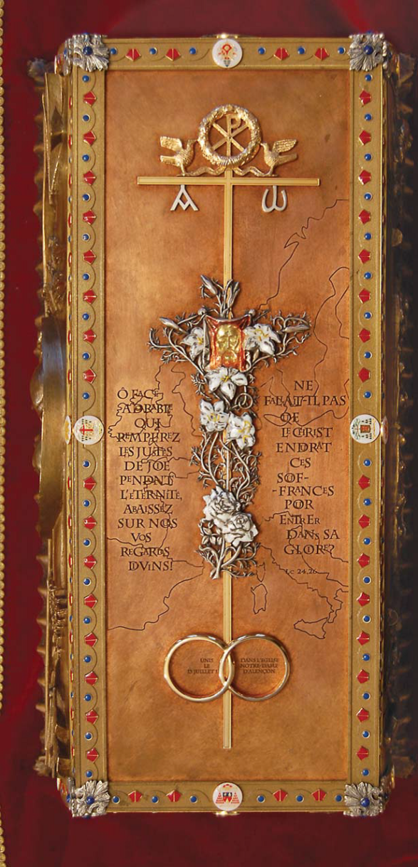
Blessed Louis and Zélie Martin’s reliquary, given by an Irish family

At a time when the family is in so much need of support, the cause of the Martin spouses is very important. A canonization is, first and foremost, the recognition that these holy persons have a mission which has been entrusted to them by the Church.

The whole procedure is expensive. It involves a lot of expenses: trips to Spain, accommodation costs, fees to be paid to specialists, duplication and publishing costs, etc…

We need your help. We would like this whole process to be supported by all those who love Louis and Zélie and who have experienced their closeness. Please consider making a gift in thanksgiving for the parents of St. Thérèse, the “father and mother more worthy of Heaven than of earth.”
http://www.therese-de-lisieux.catholique.fr/Cause-de-canonisation-des-Bienheureux-Martin.html
Do you want to contribute to the canonization process of Louis and Zélie Martin?

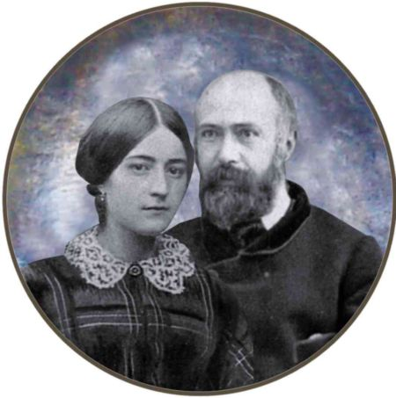

Good News!
On January 7, 2013, the diocese of Valencia (Spain), with Archbishop Carlos Osoro Sierra presiding, opened an inquiry into the presumed miracle attributed to the intercession of Blessed Louis and Zélie Martin in favour of a little girl called Carmen.
Carmen was born prematurely with multiple complications threatening her
life. A severe cerebral haemorrhage could have led to irreparable collateral damage. Her parents had not known of Louis and Zélie Martin before. On the advice of a Carmelite monastery near Valencia, which gave them the novena, they prayed with faith to the Martin spouses. For details, please visit http://tinyurl.com/d3bx7q3
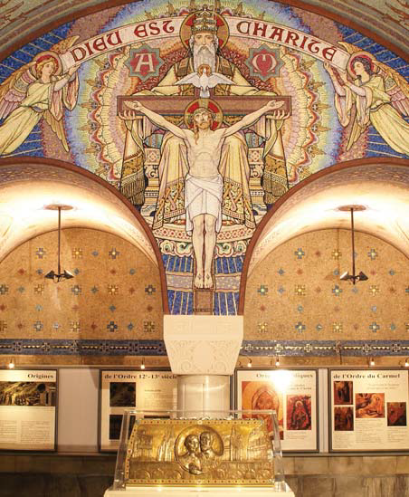Louis and Zélie’s reliquary in the Basilica
Carmen is now four years old, and her vitality, as well as a total absence of side-effects, is amazing.
For three years a team of investigators gathered the medical files and questioned the witnesses (family, doctors, etc.).
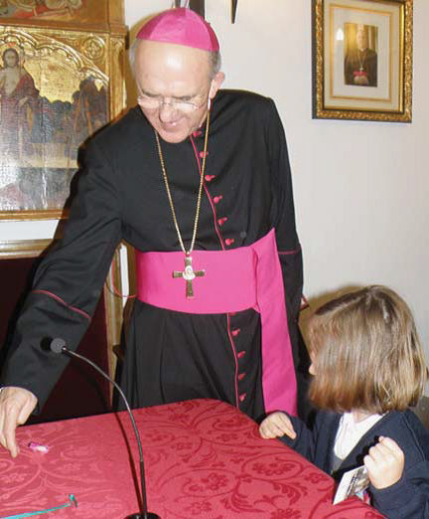
Bishop Osoro with the little Carmen
The opening of the diocesan process is a very important stage for the eventual recognition of the miracle by Rome. A final session began in Valencia in April; it will close on May 21. Then the file will be sent to the Congregation for the Causes of Saints in Rome, to be examined by seven medical specialists, by theologians, and by cardinals before it is presented to the Holy Father.

For the cause of Bl. Louis and Zelie Martin I make a donation of:
30 euros 50 euros 75 euros
100 euros 150 euros other _____ euros
Title:_________
First name:_____________________________
Surname_______________________________
Address________________________________
Address:_______________________________
Town: ________________________________
State: _____ ZIP CODE: _________________
Country:_______________________________
E-mail: ________________________________
I will donate by:
bank check or money order
Wire transfer CCP Rouen 667299D
credit card
Payable to Sanctuaire Sainte Thérèse
Mail to: Sanctuaire Sainte Thérèse
Cause des Bienheureux Martin
CS 62095
F –14102 Lisieux CEDEX
FRANCE
Card N°;_____________________________
Security code: _____ (3 last figures on the back)
Expiration date______ Name______________
Date:_________________________________
Signature:_____________________________

