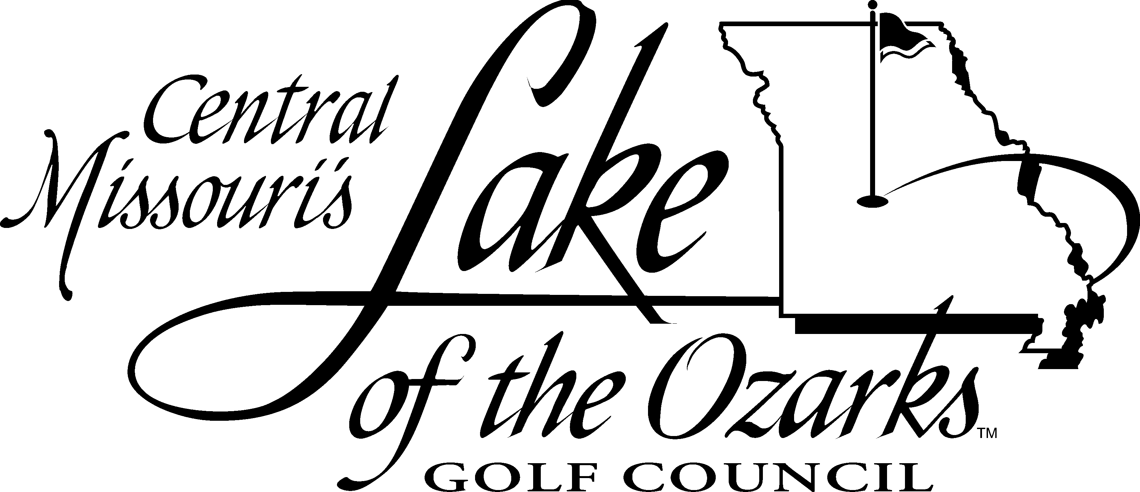

Think Spring –
Think Green!

Temperatures are gradually rising … the days are getting longer … and spring will be here soon. And that means it’s time to start thinking about golf on the Lake of the Ozarks Golf Trail. (Some of us think about golf year-round!)

If you’re thinking about golf, you should think about getting a 2014 Golfing Green Card. If you’re not familiar with the Golfing Green Card, it’s a way for members or season pass holders at Lake of the Ozarks golf courses to play each Lake golf course twice, just for the cost of cart fees.

It’s a great deal! In 2014, the Green Card will let you play twice at 13 great Lake-area courses. If you’re a frequent golfer, this is a deal you won’t want to miss. Check out the backside for Green Card rules and fees. Please note there is a new rate schedule for 2014. More details are on the reverse side.

Order your 2014 Green Card today for $150.00, and buy an additional card for only $125. That way, you’ll be ready when spring gets here!

Sincerely,
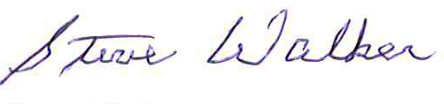
Steve Walker
Executive Director
Walker@TBWGroup.net

- - - - - - - - - - - - - - - - - - - - - - - - - - - - - - - - - - - - - - - - - - - - - - - - - - - - - - - - - - - - - - -
YES! I want to order a 2014 Golf Trail Green Card today!

Complete and mail this form with your payment (check or money order only, payable to Lake of the Ozarks Golf Council) to:
Lake of the Ozarks Golf Council, 125 East High St., Suite 200 Jefferson City, MO 65101 – Phone: 573-636-7842 or 1-800-490-8474

Name ______________________________________________________ First Card Ordered…… $150

Your Club __________________________________________________ Additional Card……… $125
_________
Daytime Phone ______________________________________________
TOTAL ENCLOSED $ _________
Mailing Address _____________________________________________

City _________________________ State _________ Zip ____________

Your Email Address __________________________________________
Green Card Fee (includes program costs and cart rental):
* For 2014, there is a new Green Card Fee in place. Please note that there is now an adjusted fee for those wishing to play prior to 12 Noon and a standard rate for those wishing to play after 12 Noon. Please see the fee schedule below.
Participating Course: Green Card Fee:* (18 holes) Telephone: Before 12 Noon* After 12 Noon*
Bear Creek Valley Golf Club $32.00 $22.00 573-302-1000
The Golf Club at Deer Chase $20.50 $20.50 573-346-6117
Dogwood Hills Golf Resort $22.00 $20.00 573-348-3153
Eldon Golf Club $28.00 $25.00 573-392-4172
Indian Rock Golf Course $24.00 $24.00 573-372-3023
Lake Valley Country Club $25.00 $25.00 573-346-7218
Old Kinderhook Golf Resort $39.00 $25.00 573-346-4444
Osage National Golf Resort $39.00 $25.00 573-365-1950
Rolling Hills Country Club $16.00 $16.00 573-378-5109
The Ridge Course $39.00 $27.00 573-365-8544
Sycamore Creek Golf Club $24.00 $22.00 573-348-9593
Tan-Tar-A Resort $35.00 $24.00 573-348-8521

2014 Golf Trail Golfing Green Card rules:
• The Golfing Green Card is valid Monday through Thursday (tournaments and holidays
excluded), Jan. 1 through Dec. 31, 2014. It is also valid for weekend play (Friday/Saturday/
Sunday) in January, February, November and December.
• Card is valid for two 18-hole rounds at each participating course.
• Tee times scheduled for before 12 Noon are subject to an adjusted rate as noted
above.
• Golfer may call up to two days in advance for tee times. Be sure to mention that you are
using a Golfing Green Card.
• Card can be used only by the person(s) listed on the individual’s home club membership
or season pass. Note: Green Card holder may use it to take a guest when playing at any
participating course. This counts as two rounds of golf.
• Home club membership card or season pass, photo ID and Green Card must be presented
when registering to play.
• Card is not good with any other special offer or discount.
• Green Cards are non-transferable.
• Golfers may purchase two cards for 2014 (individual or family membership).

125 E. High Street, Suite 200, Jefferson City, MO 65101
Phone (toll free): 800-490-8474 | Fax: 573-635-8494

