Charlie’s Compost: What’s in the Bag?

Designer Compost Bringing New Life to Your Soil and Potting Medium

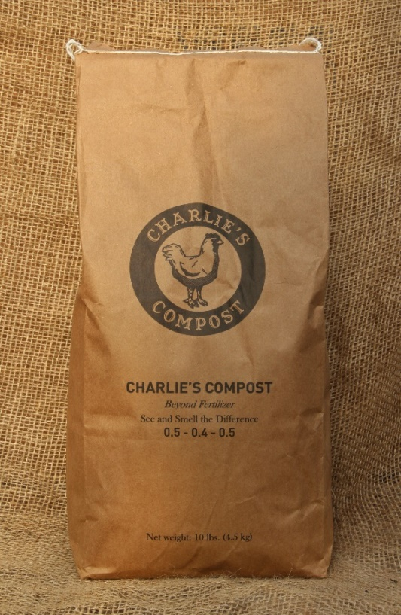
A simple analysis listing contents and statistics is only a very small part of the Charlie’s Compost story. How individual contents come together forming a finished product that becomes more than the mere listing of ingredients is a fascinating flow of events. How the designer compost joins your soil or potting medium completes a story with a happy ending.

Charlie’s Compost is designed to follow a natural flow, a progression of all natural and organic, into becoming new life for your soil.

The composting process begins with the prime ingredient of chicken manure. But, before the manure there is the question what can make this manure the best premium organic ingredient available? Before the chickens arrive a bedding of wood shavings treated with biochar is readied for them. The combination of shavings and biochar is prepped with Charlie’s Compost and Charlie’s compost tea. The tea is made up of worm casings, Charlie’s Compost, and is activated with a blend of sea weeds including kelp; humic acid and other botanical powders in an OMRI proprietary mix. The biochar is activated and mineralized becoming a condominium for microbials from the compost and tea. Again, the ingredients become so much more than the individual elements.

The bedding has provided a better quality of life for the chickens and they show their gratitude with premium poop. I have yet to detect any odor associated with chickens and their manure either when walking by exhaust fans on a visit to the houses, or when working with the product in my garden.

When chicks move out the bedding and manure base they created for premium natural fertilizer and soil amendment is recycled to large rows where an 8 to 10 week process begins. Be it your back yard or a commercial enterprise, basics of good compost remain the same. The right mix of green and brown, the correct temperature and turning.
Charlie’s Compost employs a Compost Dashboard management system which is key to the quality and life –giving ingredients found in every bag purchased. Moisture levels, temperature, and timing of turning are closely monitored at all times, as is the timing for blending other ingredients into the mix.

Green grasses harvested from an idled organic field become a part of the compost mix along with straw to reach an exact ratio of carbon and nitrogen. Compost from previous completed piles introduces microbials and nutrients as the heat builds in each row. Clean clay soil from the farm is added along with untreated water from a lake. Particles of clay soil are used to capture nutrients as the pile works similarly to the biochar activity. Charlies’ Compost is unique in using clean clay in their product.

Rows are turned and mixed by a large machine specifically designed for the task. As the rows are turned inoculants are added at each different heat phase enhancing microbial levels. The compost is mineralized with rock dust and sea salts. Rows are kept covered at all times to control moisture levels.

Each time we dig in our gardens a web of life we call soil or dirt is disturbed. Potting medium is sterile and needing fertilizer and amendments. The process ending in a bag of Charlie’s designer compost becomes the beginning of new life for your garden soil or potting medium.

