Testimonial

I was going to wait until my experiment using Charlie’s Compost finished up for the season, but I just cannot wait to tell you all about my story now.

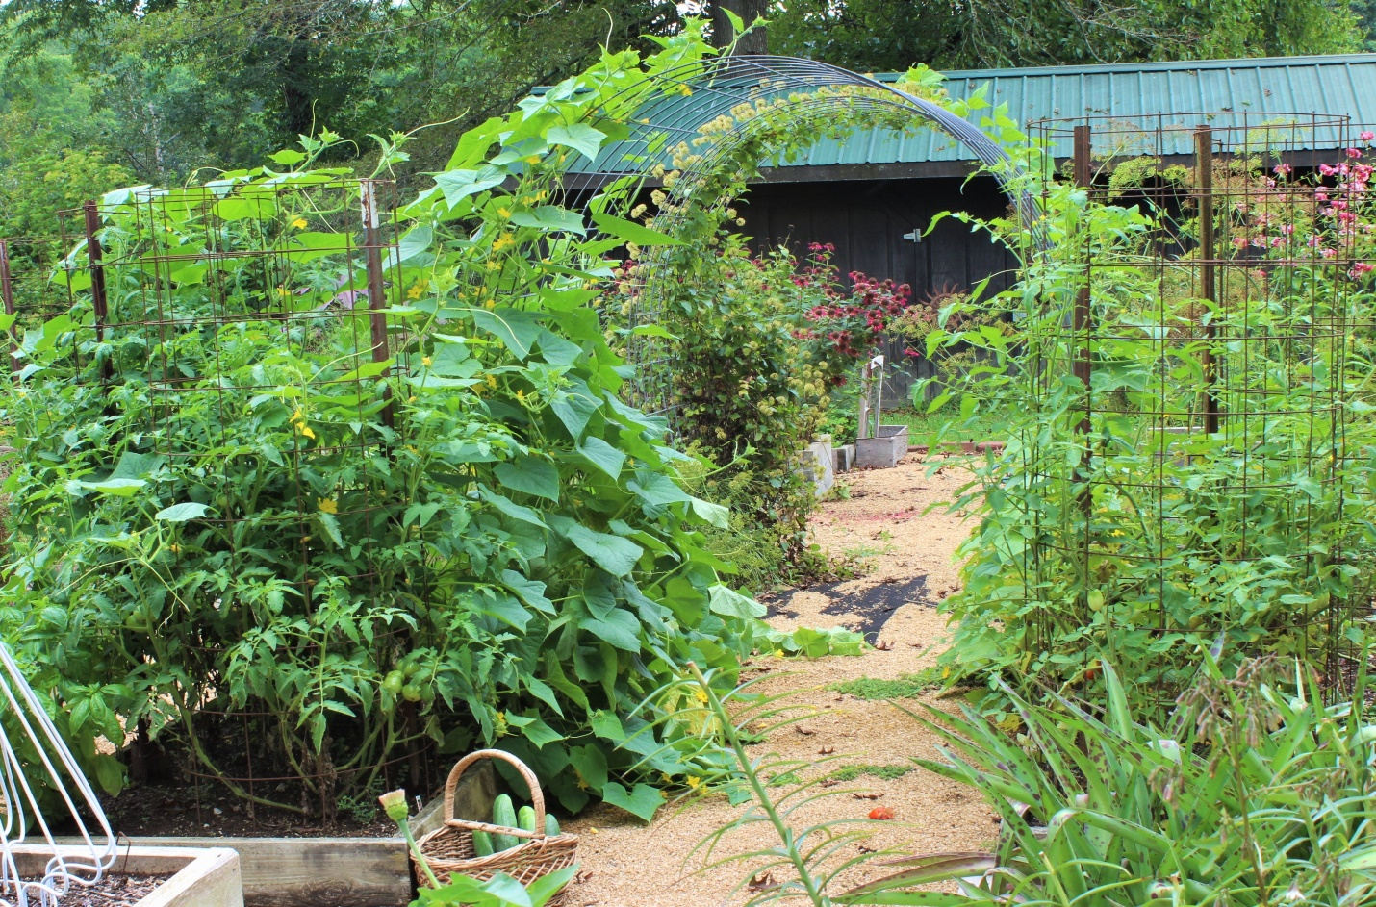

I talked my wife into letting me use two of her raised beds. Each one is 4 feet by 8 feet, 8 inches deep. They are separated by a 3 foot path and there is a cattle panel arch joining the two. Being the same size and depth with the same exposure they make a perfect place to trial your product.

One bed had a top dressing of two bags of Charlie’s Compost that was turned over with a spade and thoroughly mixed. The other bed was freshened up by loosening the soil, but no compost added. Same plants were transplanted in each bed at the same time.

Not knowing how your product was going to affect the plants I probably over did it when transplanting. I put one Basil plant, two heirloom tomatoes, two green peppers and a cucumber in my bed. Same went into the other bed. Sure looked like plenty of space at the time. Now my Charlie’s bed is crammed full of plants. Not so much the other bed.

The tomatoes are at the top of their 5 foot tall supports, completely filling in the cages with deep green lush foliage and hanging heavy with green tomatoes. Basil and green peppers are covered with glossy green leaves and blooms. But what I really wanted to tell you about is my cucumber vine.

I am close to being addicted to cucumbers, so I could not be happier with results this year. The one vine in the bed with your product is going up the trellis and over 7 feet tall now. It is also rambling down out of the bed and into the aisles on both sides. It has laced itself into the tomato cages and is still going. Covered in blooms and small cukes. Thus far I have been picking 5 to 6 cucumbers off the Charlie’s Compost bed to every cucumber coming from the bed with no compost. Sweetest most brittle and crunchy cucumbers I have ever eaten. And the bed shows no signs of yellowing of slowing down production.

I have to be honest with you. Had I not grown these transplants and seen for myself, I am not sure I would have believed me and my tall tale about my cucumbers. You can see for yourself in the photos I am sending. Proof positive there will not be a bed without Charlie’s Compost next year.

You really do have to try it for yourself.

Gene Bush, Southern Indiana, being allowed to mess around in my wife, JoAn Riley’s, garden.

