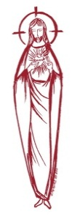
SACRED HEART PARISH

Sacred Heart Parish Founded 1814, The First Catholic Parish in the STate of New Jersey

Sacred Heart Church, 343 South broad Street, Trenton, New Jersey 08608

Holy Cross Church, 233 Adeline Street, Trenton, New Jersey 08611

ALL ARE WELCOME

Whatever your present status in the Catholic Church, whatever your current family or marital situation,

Whatever your past or present religious affiliation, whatever your personal history, age, background, or

race, whatever your own self-image or esteem, you are invited, welcomed, accepted, loved and

respected at the Parish of the Sacred Heart.

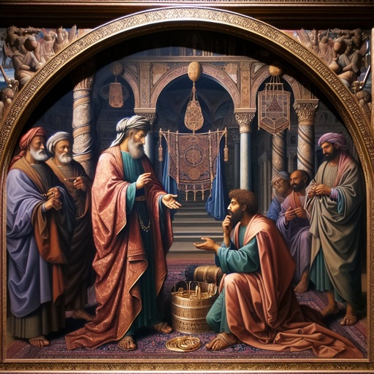

The Parable of The Unforgiving Servant

PASTOR

Rev. Msgr. Dennis A. Apoldite
frdennis@trentonsacredheart.org
PAROCHIAL VICAR
Rev. Charles Muorah 609-393-4826 ext. 108
DEACON : Dr. Christian Nnajiofor
Business ADMINISTRATOR/ADMINISTRATIVE ASSISTANT
John DeSantis: secretary@trentonsacredheart.org
Administrator of religious education
Mary Tovar: reled@trentonsacredheart.org

SACRED HEART PARISH OFFICE

9:00am – 4:00pm Monday – Friday

343 South Broad Street, Trenton, NJ 08608

Phone: (609) 393-2801 ~ Fax: (609) 989-8997 www.trentonsacredheart.org

Sacred Heart CHURCH
Monday, Tuesday, Wednesday and Friday: 12:10 Noon
Saturday 5:15 PM Sunday 9:00 and 11:15 AM
HOLY CROSS CHURCH
Saturday 4:00 PM Sunday 10:00 AM ~ 12:00 Noon Polish
EUCHARISTIC ADORATION
First Saturday of the Month 2:30 to 3:30 pm in HCC
SACRAMENTAL RECORDS
Sacred Heart Church, Saint John’s Church, Saint Francis Church, Saints Peter and Paul Church, Saint Stanislaus Church, Holy Cross Church, Blessed Sacrament Church, Our Lady of Divine Shepherd Church, Blessed Sacrament/Our Lady of Divine Shepherd Parish and Divine Mercy Parish

TWENTY-FOURTH SUNDAY IN

ORDINARY TIME

September 13, 2026
MASS INTENTIONS
Saturday, September 12
4:00 pm HC ~ Ruth Tydryszewski Waltz,
Daniel Bliznawiczus, and Stanley & Dolores Krysztofik
5:15 pm SH ~ Reneé Dellaira
Sunday, September 13
9:00 SH ~ the Holy Name Society, John & Viola Bugdal,
and Joe & Ruth Toomey
10:00 HC ~ Maryann Walz
11:15 SH ~ Fredrick Romanowsky
12:00 HC Polish ~ intentions of the People of the Parish Monday, September 14
12:10 SH ~ Special Intention
Tuesday, September 15
12:10 SH ~ No Mass ~ Priests Convocation
Wednesday, September 16
12:10 SH ~ No Mass ~ Priests Convocation
Thursday, September 17
12:10 SH ~ No Mass ~ Priests Convocation
Friday, September 18
12:10 SH ~ Gus Burson
Saturday, September 19
4:00 pm HC ~ Roger Kuhns, Richard Tydryszewski, and
Special Intention
5:15 pm SH ~ John Tuck, and Reneé Valentino Dellaira
Sunday, September 20
9:00 SH ~ Juan Ramon Davila and Steve Saganowski
10:00 HC ~ Fritz Gerald Delva
11:15 SH ~ Eileen Kostrzewa and Jan Wilczek
12:00 HC Polish ~ intentions of the People of the Parish

OUR SICK LIST
Barbara Burrows, Elizabeth Gorrel, Ellen Dondero, Stephanie McGinley, Dolores Lukowicz, Lesia DiVeonica, Alice Buck, Heather Allaire, Ronald & Lorraine Karczewski, John Hardiman, John Testa, Marlene Harris, Karen Vernon-Stewart, Msgr Michael Walsh, Diane Sabourin, Chet Siwczak, Donna Brodowski Longo, Tim Kuser, Susan Smith, Jack McDonough, Jim Duncan, Alexander Jaeploe, Nepoleon Jaeploe, Jean Ianni, Susan McCool, Doris Feehan, Anthony Pitonyak, Mary Komjathy, Fr J C Garret, Anna Solack, Lois Gold, Augustine Chavez, Lynda Costantini, Robert Paci, Dolores Klama, Nancy Dee, Judy Dee, Jon Arch, Lorraine Rogers, Bob Kuzma, Alexander Ladnyk, Michael Szymelewicz, Deahtron Wm. Crosland, Gerald Caruso, Paul Sootkoos, Richard Buckley, Joan Buckley, Kevin Hogan, Connie Swiderski, Thomas Erni, Michael Simoliga, Laverne Major, David Carver, Doreen Nemeth, Vincent Cooper Jr., Barbara Ardery, Karl Megules, Dan Breese Jr., Joseph Caivano, Greg Schafer, Chris, Tom, Melvin Lee, Amy Birk.

OUR DECEASED
Msgr Michael Walsh, Charles Sheehan, Marge Caldwell-Wilson, and our friends at South Village, Riverside Nursing and Rehabilitation Center, Mill House and Trenton Gardens Rehabilitation and Nursing Center.
MINISTRY SCHEDULE
(Subject to change)
Saturday, September 12
4:00pm HCC ~ Fr Charles L.: Herpel EM Lennon
5:15pm SHC ~ Msgr. Dennis L.: C Hernandez EM Breuer’s
Sunday, September 13
9:00 SHC ~ Msgr. Dennis L.: Valentino Em R&K Figueroa, Green
10:00 HCC ~ Fr. Charles L.: Nnajiofor EM Kamah
11:15 SH Msgr. Dennis L.: Rhodes-Rogers EM S Jurczynski N Rhodes
12:00 HCC Polish ~Fr Marian L Ewa, Gosia

Saturday, September 19
4:00pm HCC ~ Fr Charles L.: V Zielinski EM Mich
5:15pm SHC ~ Msgr. Dennis L.: R Hernandez EM DuMont Burke
Sunday, September 20
9:00 SHMsgr. Dennis L.: Wengryn EM H&M Figueroa, K Jurczynski
10:00 HCC ~ Fr. Charles L.: Nwachukwu Em Williams
11:15 SHC ~ Msgr. Dennis L.: Tovar EM Allaire Bautz
12:00 HCC Polish ~ Fr Charles L: Anna, Gosia

A PRAYER FOR OUR MILITARY
Lord, hold our troops in your loving hands. Protect them as they protect us. Bless them and their families for the selfless acts they perform for us in our time of need. We ask this in the name of Jesus, our Lord and Savior…Amen.
Ricky Bailey, Jr
Sergeant Isabel Marie Figueroa
Staff Sergeant Nathaniel King
Terrance Livingston, Jr.
LT Madeleine Rizzuto USCG
1stLt Wayne D. Staub USMC

WEEKLY COLLECTION
Last weekend’s collection amounted to: $9,626.00
Capital Campaign ~ Project 210
Donations amount to $314,033.00
Annual Catholic Appeal Goal: $39,000.00
Pledged: $53,962.00 (138%) Paid: $51,017.00 (131%)
Total Donors: 154 (100%)
Congratulations on reaching your
donor incentive goal!
Readings for the Week
Twenty-fourth Week in Ordinary Time
Sunday Sir 27:30—28:7; Rom 14:7-9; Mt 18:21-35
Monday Nm 21:4b-9; Phil 2:6-11; Jn 3:13-17
Tuesday 1 Cor 12:12-14, 27-31a; Jn 19:25-27
Wednesday 1 Cor 12:31—13:13; Lk 7:31-35
Thursday 1 Cor 15:1-11; Lk 7:36-50
Friday 1 Cor 15:12-20; Lk 8:1-3
Saturday 1 Cor 15:35-37, 42-49; Lk 8:4-15

PROMISE TO PROTECT
The Diocese of Trenton is committed to the norms of the U.S. Bishop’s Charter for the Protection of Children and Young People in regard to the reporting and investigation of sexual abuse allegations involving minors. If you have been sexually abused as a minor by anyone representing the Catholic Church, you can report that abuse through the diocesan Hotline: abuseline@dioceseoftrenton.org or 1-888-296-2965. Allegations are reported to the appropriate law enforcement agencies.

PRIEST ANNUAL CONVOCATION
This week on Tuesday, Wednesday and Thursday, the priests of our Diocese will be attending the annual convocation, a time of prayer, renewal and fraternity. We encourage you to pray for all the priests of our Diocese especially this week. Please note that there will not be a 12:10 noon Mass at Sacred Heart Church on Tuesday, Wednesday and Thursday.

FOOD OUTREACH PROGRAM
Next weekend is Food Collection Weekend. Food Bagging will be held on Monday, September 21st at 9:30am in Toomey Hall, with Food Distribution on Tuesday, September 22nd at 1:30pm

SACRED HEART HOLY NAME SOCIETY
The Sacred Heart Holy Name Society will resume it's 2026 meeting schedule. The monthly Corporate Communion will be on Sunday, September 13th at 9:00 Mass at Sacred Heart Church



NEXT SUNDAY

All of our young people of the parish are invited to participate in the blessing of their school backpacks on Sunday, September 20th at the 9:00 Mass. No matter what school you attend or Religious Education Program you are enrolled, please bring your backpacks with a few of your book so they can be blessed for the new academic year. We look forward to seeing you and your family at the 9:00 Mass on the 20th .

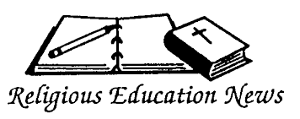
OPENING DAY IS THIS SUNDAY
Classes begin on September 13th with a meeting in Sacred Heart Church at 10:00 AM for all parents or Guardians and students. Following the meeting, families will have the opportunity to meet with their child's catechist and attend their individual class sessions. We look forward to welcoming both returning and new families as we begin another year of growing together in faith.

OCIA
BEGINS ON SUNDAY SEPTEMBER 20, 2026
The Order of Christian Initiation for Adults (OCIA)
is the process through which adults are welcomed into the Catholic Church and receive the sacraments of Baptism, Eucharist and Confirmation. The sacraments of initiation are celebrated each year at the Easter Vigil. For those who have already been baptized Catholic but have not yet received the sacrament of Communion and/or Confirmation, the OCIA process is the right path to complete your sacraments of initiation. Whether you are coming from a different Christian tradition, have never been baptized, or are seeking to complete your sacraments, the OCIA process is tailored to meet your individual needs and background. For more information, call Msgr. Dennis at 609.393.2801, ext. 102.

ANNUAL CATHOLIC APPEAL REPORT
Thanks to the extraordinary generosity of donors across the Diocese, the 2026 Annual Catholic Appeal has not only reached its goal of $6 million, but has now surpassed it. This is a remarkable achievement and a testament to the faith, commitment, and stewardship of so many people who believe in the mission of our Church. On the parish level, Sacred Heart parish has reached the incentive goal of 154 donors, which entitles them to a rebate of $1,950.00. Thank you to all who have participated in this year’s appeal.
SUMMER SERIES OF THE USA SAINTS
St. Junípero Serra (1713-1784)
Founder of the Spanish missions in California
Patron saint of California, Hispanic Americans and vocations
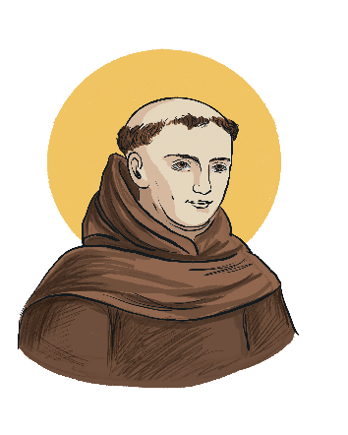
At St. Junípero Serra’s canonization in 2015, the only canonization on U.S. soil, Pope Francis said we are all called to imitate St. Junípero Serra. “He was the embodiment of ‘a Church which goes forth,’ a Church which sets out to bring everywhere the reconciling tenderness of God,” Pope Francis said at the Basilica of the National Shrine of the Immaculate Conception in Washington.
As a young man in Spain, St. Junípero Serra joined the Franciscan order and began a short career as a professor, famous for his preaching. When he was 35, he began to yearn for the life of a missionary in the New World. He left everything behind and boarded a ship bound for Vera Cruz, Mexico. On his way to Mexico City, an insect bite infected his leg so badly that walking pained him for the rest of his life but it did not stop him. He founded nine of the 21 California missions. Even through painfully hobbled, he traveled up and down the coast of modern-day California, motivated by his concern for the native population and his zeal for sharing the Christian faith. He is buried at the Carmel Mission. He is venerated by Catholics and non-Catholics alike as the apostle and father of California.
Feast day: July 1.

BISHOP’S ANNIVERSARY BLESSING MASS
Join us in celebrating Marriage as we recognize those couples celebrating their first, twenty-fifth, or fiftieth (plus) year of marriage.
Sunday, October 4, 2026
Cathedral of St. Mary of the Assumption
On Sunday, October 4th, the diocese will celebrate those couples in Burlington and Mercer counties at the Cathedral in Trenton. On Sunday, October 18th, we will celebrate those couples in Monmouth and Ocean Counties at the Co-Cathedral in Freehold. We hope that you will join us this year in celebrating this beautiful vocation and sacrament. Both Masses begin at 3:00 PM.

THE EXALTATION OF THE CROSS
Early in the fourth century, Saint Helena, mother of the Roman Emperor Constantine, went to Jerusalem in search of the holy places of Christ’s life. She razed the second-century Temple of Aphrodite, which tradition held was built over the Savior’s tomb, and her son built the Basilica of the Holy Sepulcher on that spot. During the excavation, workers found three crosses. Legend has it that the one on which Jesus died was identified when its touch healed a dying woman. The cross immediately became an object of veneration. At a Good Friday celebration in Jerusalem toward the end of the fourth century, according to an eyewitness, the wood was taken out of its silver container and placed on a table together with the inscription Pilate ordered placed above Jesus’ head: Then “all the people pass through one by one; all of them bow down, touching the cross and the inscription, first with their foreheads, then with their eyes; and, after kissing the cross, they move on.” To this day, we celebrate the Exaltation of the Holy Cross on the September anniversary of the basilica’s dedication. The feast entered the Western calendar in the seventh century after Emperor Heraclius recovered the cross from the Persians, who had carried it off in 614, 15 years earlier. According to the story, the emperor intended to carry the cross back into Jerusalem himself, but was unable to move forward until he took off his imperial garb and became a barefoot pilgrim. The feast day is celebrated September 14th.

OUR LADY OF SORROWS

Feast Day September 15

The title, Our Lady of Sorrows, given to our Blessed Mother focuses on her intense suffering and grief during the passion and death of our Lord. Traditionally, this suffering was not limited to the passion and death event; rather, it comprised the seven dolors or seven sorrows of Mary, which were foretold by the Priest Simeon who proclaimed to Mary, This child [Jesus] is destined to be the downfall and the rise of many in Israel, a sign that will be opposed and you yourself shall be pierced with a sword so that the thoughts of many hearts may be laid bare (Luke 2:34-35). These seven sorrows of our Blessed Mother included the flight of the Holy Family into Egypt; the loss and finding of the child Jesus in the Temple; Mary's meeting of Jesus on His way to Calvary; Mary's standing at the foot of the cross when our Lord was crucified; her holding of Jesus when He was taken down from the cross; and then our Lord's burial. In all, the prophesy of Simeon that a sword would pierce our Blessed Mother's heart was fulfilled in these events. For this reason, Mary is sometimes depicted with her heart exposed and with seven swords piercing it. More importantly, each new suffering was received with the courage, love, and trust that echoed her fiat, let it be done unto me according to Thy word, first uttered at the Annunciation. This Feast of Our Lady of Sorrows grew in popularity in the 12th century, although under various titles. Granted, some writings would place its roots in the eleventh century, especially among the Benedictine monks. By the fourteenth and fifteenth centuries, the feast and devotion were widespread throughout the Church.

Interestingly, in 1482, the feast was officially placed in the Roman Missal under the title of Our Lady of Compassion, highlighting the great love our Blessed Mother displayed in suffering with her Son. The word compassion derives from the Latin roots cum and patior which means to suffer with. Our Blessed Mother's sorrow exceeded anyone else's since she was the mother of Jesus, who was not only her Son but also her Lord and Savior; she truly suffered with her Son. In 1727, Pope Benedict XIII placed the Feast of Our Lady of Compassion in the Roman Calendar on Friday before Palm Sunday. This feast was suppressed with the revision of the calendar published in the Roman Missal of 1969.

In 1668 the feast in honor of the Seven Dolors was set for the Sunday after September 14, the Feast of the Holy Cross. The feast was inserted into the Roman calendar in 1814, and Pope Pius X fixed the permanent date of September 15 for the Feast of the Seven Sorrows of the Blessed Virgin Mary (now simply called the Feast of Our Lady of Sorrows). The key image here is our Blessed Mother standing faithfully at the foot of the cross with her dying Son: the Gospel of St. John recorded, Seeing His mother there with the disciple whom He loved, Jesus said to His mother, 'Woman, there is your son.' In turn He said to the disciple, 'There is your mother.' (John 19:26-27). The Second Vatican Council in its Dogmatic Constitution on the Church wrote, A...She stood in keeping with the divine plan, suffering grievously with her only-begotten Son. There she united herself, with a maternal heart, to His sacrifice, and lovingly consented to the immolation of this Victim which she herself had brought forth (#58).

Focusing on the compassion of our Blessed Mother, our Holy Father, Pope John Paul II, reminded the faithful, Mary Most Holy goes on being the loving consoler of those touched by the many physical and moral sorrows which afflict and torment humanity. She knows our sorrows and our pains, because she too suffered, from Bethlehem to Calvary. 'And thy soul too a sword shall pierce.' Mary is our Spiritual Mother, and the mother always understands her children and consoles them in their troubles. Then, she has that specific mission to love us, received from Jesus on the Cross, to love us only and always, so as to save us! Mary consoles us above all by pointing out the Crucified One and Paradise to us! (1980).

Therefore, as we honor our Blessed Mother, our Lady of Sorrows, we honor her as the faithful disciple and exemplar of faith. Let us pray as we do in the opening prayer of the Mass for this feast day: Father, as your Son was raised on the cross, His Mother Mary stood by Him, sharing His sufferings. May your Church be united with Christ in His suffering and death and so come to share in His rising to new life. Looking to the example of Mary, may we too unite our sufferings to our Lord, facing them with courage, love, and trust.

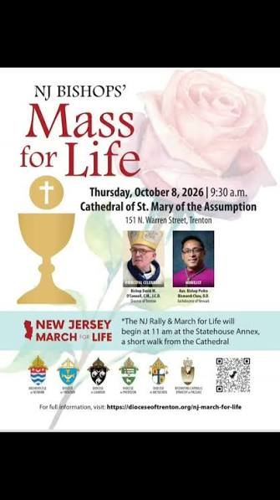

State-wide Mass for Life set for October. 8

CATHOLICS AND PEOPLE OF GOOD WILL FROM ACROSS THE STATE will gather in prayer and public witness for the unborn during a day of events Oct. 8 in Trenton at a pivotal time for the pro-life movement.

“Catholics in New Jersey live in the very challenging reality of [an] extreme abortion-permissive culture, which is even more reason for us to gather in Trenton in force as a united front, under the prayerful leadership of all our bishops,” said Rachel Hendricks, diocesan coordinator of respect life ministry.

The first stop for the faithful will be the NJ Bishops’ Mass for Life. Bishop David M. O’Connell, C.M., Diocese of Trenton, will be the host and principal celebrant of the Mass, which will begin at 9:30 a.m. in St. Mary of the Assumption Cathedral. Auxiliary Bishop Pedro Bismarck Chau of the Archdiocese of Newark will serve as the homilist.

