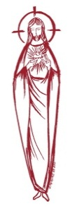
SACRED HEART PARISH

Sacred Heart Parish Founded 1814, The First Catholic Parish in the STate of New Jersey

Sacred Heart Church, 343 South broad Street, Trenton, New Jersey 08608

Holy Cross Church, 233 Adeline Street, Trenton, New Jersey 08611

ALL ARE WELCOME

Whatever your present status in the Catholic Church, whatever your current family or marital situation,

Whatever your past or present religious affiliation, whatever your personal history, age, background, or

race, whatever your own self-image or esteem, you are invited, welcomed, accepted, loved and

respected at the Parish of the Sacred Heart.

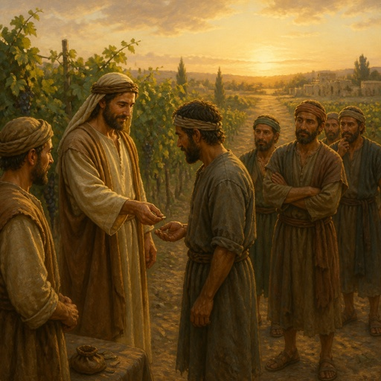

“Take what belongs to you and go.”

PASTOR

Rev. Msgr. Dennis A. Apoldite
frdennis@trentonsacredheart.org
PAROCHIAL VICAR
Rev. Charles Muorah 609-393-4826 ext. 108
DEACON : Dr. Christian Nnajiofor
Business ADMINISTRATOR/ADMINISTRATIVE ASSISTANT
John DeSantis: secretary@trentonsacredheart.org
Administrator of religious education
Mary Tovar: reled@trentonsacredheart.org

SACRED HEART PARISH OFFICE

9:00am – 4:00pm Monday – Friday

343 South Broad Street, Trenton, NJ 08608

Phone: (609) 393-2801 ~ Fax: (609) 989-8997 www.trentonsacredheart.org

Sacred Heart CHURCH
Monday, Tuesday, Wednesday and Friday: 12:10 Noon
Saturday 5:15 PM Sunday 9:00 and 11:15 AM
HOLY CROSS CHURCH
Saturday 4:00 PM Sunday 10:00 AM ~ 12:00 Noon Polish
EUCHARISTIC ADORATION
First Saturday of the Month 2:30 to 3:30 pm in HCC
SACRAMENTAL RECORDS
Sacred Heart Church, Saint John’s Church, Saint Francis Church, Saints Peter and Paul Church, Saint Stanislaus Church, Holy Cross Church, Blessed Sacrament Church, Our Lady of Divine Shepherd Church, Blessed Sacrament/Our Lady of Divine Shepherd Parish and Divine Mercy Parish

TWENTY-FIFTH SUNDAY IN

ORDINARY TIME

September 20, 2026
MASS INTENTIONS
Saturday, September 19
4:00 pm HC ~ Roger Kuhns, Richard Tydryszewski, and
Special Intention
5:15 pm SH ~ John Tuck, and Reneé Valentino Dellaira
Sunday, September 20
9:00 SH ~ Juan Ramon Davila and Steve Saganowski
10:00 HC ~ Fritz Gerald Delva
11:15 SH ~ Eileen Kostrzewa and Jan Wilczek
12:00 HC Polish ~ intentions of the People of the Parish
Monday, September 21
12:10 SH ~ the Deceased Priests and Sisters of
Sacred Heart Parish
Tuesday, September 22
12:10 SH ~ Maureen Anne Jones
Wednesday, September 23
12:10 SH ~ Gerald Apoldite
Thursday, September 24
12:10 SH ~ No Mass
Friday, September 25
12:10 SH ~ Brenda Southwick
Saturday, September 26
4:00 pm HC~ Vilma Mathews, Thomas & Pauline Lukowicz,
and Special Intention
5:15 pm SH ~ Frank & Betty Czap, and Reneé Dellaira
Sunday, September 27
9:00 SH ~ Juan Ramon Davila and Steve Saganowski
10:00 HC ~ intentions of the People of the Parish
11:15 SH ~ Steven Saganowski, and Elizabeth Gorrel (L)
12:00 HC Polish ~ Msgr Michael Walsh
OUR SICK LIST
The Twin Girls, John Walker, Barbara Burrows, Elizabeth Gorrel, Ellen Dondero, Stephanie McGinley, Dolores Lukowicz, Lesia DiVeonica, Alice Buck, Heather Allaire, Ronald & Lorraine Karczewski, John Hardiman, John Testa, Marlene Harris, Karen Vernon-Stewart, Diane Sabourin, Chet Siwczak, Donna Brodowski Longo, Tim Kuser, Susan Smith, Jack McDonough, Jim Duncan, Alexander Jaeploe, Nepoleon Jaeploe, Jean Ianni, Susan McCool, Doris Feehan, Anthony Pitonyak, Mary Komjathy, Fr J C Garret, Anna Solack, Lois Gold, Augustine Chavez, Lynda Costantini, Robert Paci, Dolores Klama, Nancy Dee, Judy Dee, Jon Arch, Lorraine Rogers, Bob Kuzma, Alexander Ladnyk, Michael Szymelewicz, Deahtron Wm. Crosland, Gerald Caruso, Paul Sootkoos, Richard Buckley, Joan Buckley, Kevin Hogan, Connie Swiderski, Thomas Erni, Michael Simoliga, Laverne Major, David Carver, Doreen Nemeth, Vincent Cooper Jr., Barbara Ardery, Karl Megules, Dan Breese Jr., Joseph Caivano, Greg Schafer, Chris, Tom, Melvin Lee, Amy Birk.

OUR DECEASED
Joseph Di Paolo, Sr., Fr John Wake, Msgr Michael Walsh, and Charles Sheehan, and our friends at South Village, Riverside Nursing and Rehabilitation Center, Mill House and Trenton Gardens Rehabilitation and Nursing Center.
MINISTRY SCHEDULE
(Subject to change)

Saturday, September 19
4:00pm HCC ~ Fr Charles L.: V Zielinski EM Mich
5:15pm SHC ~ Msgr. Dennis L.: R Hernandez EM DuMont Burke
Sunday, September 20
9:00 SHMsgr. Dennis L.: Wengryn EM H&M Figueroa, K Jurczynski
10:00 HCC ~ Fr. Charles L.: Nwachukwu Em Williams
11:15 SHC ~ Msgr. Dennis L.: Tovar EM Allaire Bautz
12:00 HCC Polish ~ Fr Charles L: Anna, Gosia

Saturday, September 26
4:00pm HCC ~ Fr Charles L.: Benitez EM E Zielinski
5:15pm SHC ~ Msgr. Dennis L.: Seabrook Em Lewis Salamandra
Sunday, September 27
9:00 SHC ~ Msgr. Dennis L.: Jurczynski EM James’ Hines
10:00 HCC ~ Fr. Charles L.: Madu EM Ezeuka
11:15 SHC ~ Msgr. Dennis L.: Allaire EM Boyle Rizzuto
12:00 HCC Polish ~ Fr Marian L: Ewa, Rysiu

A PRAYER FOR OUR MILITARY
Lord, hold our troops in your loving hands. Protect them as they protect us. Bless them and their families for the selfless acts they perform for us in our time of need. We ask this in the name of Jesus, our Lord and Savior…Amen.
Ricky Bailey, Jr
Sergeant Isabel Marie Figueroa
Staff Sergeant Nathaniel King
Terrance Livingston, Jr.
LT Madeleine Rizzuto USCG
1stLt Wayne D. Staub USMC

WEEKLY COLLECTION
Last weekend’s collection amounted to: $6,828.00
Capital Campaign ~ Project 210
Donations amount to $314,033.00
Annual Catholic Appeal Goal: $39,000.00
Paid: $51,227.00 (131%) Average Gift: $351.70
Total Donors: 154 (100%)
Readings for the Week
Twenty-fifth Week in Ordinary Time
Sunday Is 55:6-9; Phil 1:20c-24, 27a; Mt 20:1-16a
Monday Eph 4:1-7, 11-13; Mt 9:9-13
Tuesday Prv 21:1-6, 10-13; Lk 8:19-21
Wednesday Prv 30:5-9; Lk 9:1-6
Thursday Eccl 1:2-11; Lk 9:7-9
Friday Eccl 3:1-11; Lk 9:18-22
Saturday Eccl 11:9—12:8; Lk 9:43b-45

PROMISE TO PROTECT
The Diocese of Trenton is committed to the norms of the U.S. Bishop’s Charter for the Protection of Children and Young People in regard to the reporting and investigation of sexual abuse allegations involving minors. If you have been sexually abused as a minor by anyone representing the Catholic Church, you can report that abuse through the diocesan Hotline: abuseline@dioceseoftrenton.org or 1-888-296-2965. Allegations are reported to the appropriate law enforcement agencies.

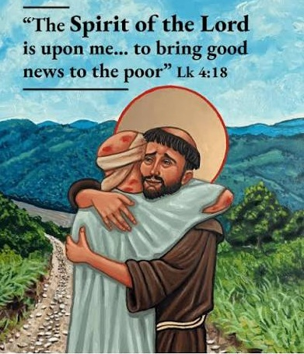
“The Spirit of the Lord is upon me…to bring good news to the poor”

Catechetical Sunday
The 2026 theme reveals Jesus’ mission and identity. Anointed by the Holy Spirit, he is sent to bring hope, healing, and freedom - especially to the poor, the brokenhearted, and the forgotten. This passage shows that the Messiah comes not with power or status, but with compassion, restoring dignity and proclaiming God’s mercy. It also becomes a model for the Church, us, which is called to continue Christ’s work by sharing the Good News and caring for those most in need. Those whom the Community has designated to serve as catechists will be called forth to be commissioned for their ministry. Catechetical Sunday is a wonderful opportunity to reflect on the role that each person plays, by virtue of Baptism, in handing on the faith and being a witness to the Gospel. Catechetical Sunday is an opportunity for all to rededicate themselves to this mission as a community of faith. The Commissioning Ceremony for our Catechist and Aides will be held at the 9:00 AM Mass at Sacred Heart Church, they include:
Mary Tovar, Nancy Breese
Andrea Flores, Rosy Flores
Kate Jurczynski, Susan Jurczynski
Sharon Lauchaire, Laura Mendez,
Zoila Mendez, Abby Miller, Jill Pienciak
Christopher Vagnozzi, Ed Wengryn

FOOD OUTREACH PROGRAM
This weekend is Food Collection Weekend. Food Bagging will be held on Monday, September 21st at 9:30am in Toomey Hall, with Food Distribution on Tuesday, September 22nd at 1:30pm



THIS SUNDAY

All of our young people of the parish are invited to participate in the blessing of their school backpacks on Sunday, September 20th at the 9:00 Mass. No matter what school you attend or Religious Education Program you are enrolled, please bring your backpacks with a few of your book so they can be blessed for the new academic year. We look forward to seeing you and your family at the 9:00 Mass on the 20th .

ALTAR ROSARY SOCIETY NEWS

The Altar Rosary Society will meet on October 4, 2026, at Sacred Heart Church. Recitation of the Rosary will begin at 8:30am, we would love to have you join us in praying the Rosary and attending the Mass at 9:00am. Following Mass a meeting is held in Toomey Hall along with light refreshments. We are always looking for new members to praise and honor the Blessed Virgin Mary. Feel free to bring a friend or family member to meet our members and see firsthand what the Altar Rosary Society represents. New ideas, new members, welcome new ways to build our church community through parish life, charitable works and fellowship. Any questions, do not hesitate to contact Mrs. Carmen Benitez, at 609-954-3058

OCIA
BEGINS THIS SUNDAY
The Order of Christian Initiation for Adults (OCIA)
is the process through which adults are welcomed into the Catholic Church and receive the sacraments of Baptism, Eucharist and Confirmation. The sacraments of initiation are celebrated each year at the Easter Vigil. For those who have already been baptized Catholic but have not yet received the sacrament of Communion and/or Confirmation, the OCIA process is the right path to complete your sacraments of initiation. Whether you are coming from a different Christian tradition, have never been baptized, or are seeking to complete your sacraments, the OCIA process is tailored to meet your individual needs and background. For more information, call Msgr. Dennis at 609.393.2801, ext. 102.
RETROUVAILLE
Retrouvaille: Rediscover the Love in Your Marriage Retrouvaille (pronounced Retro-vy) has helped tens of thousands of couples heal and strengthen their marriages. The program helps couples improve communication, increase intimacy, and find support during marriage problems, difficulties, or crises. The next program will be held October 2–4 at the Family Life Center in Malvern, PA. For more information or to register, visit MarriageHelpDelVal.org or call 215-766-3944. All inquiries are strictly confidential.

BISHOP’S ANNIVERSARY BLESSING MASS
Join us in celebrating Marriage as we recognize those couples celebrating their first, twenty-fifth, or fiftieth (plus) year of marriage.
Cathedral of St. Mary of the Assumption
On Sunday, October 4th, the diocese will celebrate those couples in Burlington and Mercer counties at the Cathedral in Trenton. On Sunday, October 18th, is for couples in Monmouth and Ocean Counties at the Co-Cathedral in Freehold. We hope that you will join us this year in celebrating this beautiful vocation and sacrament. Both Masses begin at 3:00 PM.
SUMMER SERIES OF THE USA SAINTS
St. Mother Théodore Guérin (1784-1856)
Missionary and founder of the Sisters of Providence of Saint Mary-of-the-Woods
Patron saint of Diocese of Vincennes, Indiana

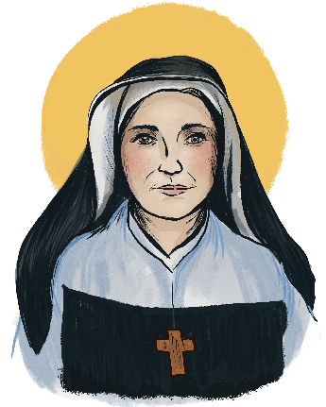

St. Théodore Guérin was born Oct. 2, 1784, in Etables, France. When she received her first Holy Communion at the age of 10, she announced to the parish priest that she would one day be a nun. At 25, she entered the Sisters of Providence of Ruillé-sur-Loir, whose mission was to educate children and to care for the poor, sick and dying. In 1840, at the age of 56, Sister Théodore was asked to lead a small band of missionary sisters to Indiana in the United States. When the sisters arrived, there was only a log cabin with a porch that served as a chapel. Though her health was suffering, Mother Théodore embraced this new task with a strong and generous will. By the time she died in 1856, St. Théodore had opened schools in Illinois and throughout Indiana. The sisters were well-established and respected. Through illness, poverty and all manner of unwelcoming circumstances, she trusted in God’s providence and lived as a model of belief in his mercy, especially when human calculations judge a task impossible. She was canonized in 2006 and is the patron saint of Indianapolis.
Feast day: October 3.



