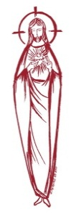
SACRED HEART PARISH

Sacred Heart Parish Founded 1814, The First Catholic Parish in the STate of New Jersey

Sacred Heart Church, 343 South broad Street, Trenton, New Jersey 08608

Holy Cross Church, 233 Adeline Street, Trenton, New Jersey 08611

ALL ARE WELCOME

Whatever your present status in the Catholic Church, whatever your current family or marital situation,

Whatever your past or present religious affiliation, whatever your personal history, age, background, or

race, whatever your own self-image or esteem, you are invited, welcomed, accepted, loved and

respected at the Parish of the Sacred Heart.

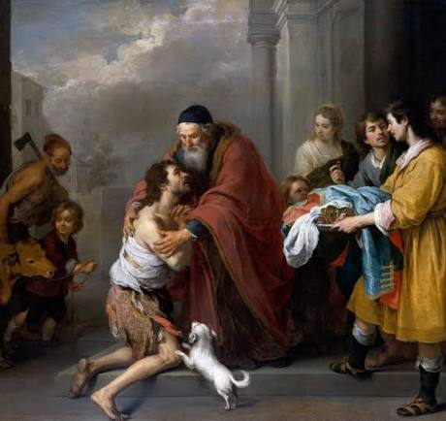

The return of the Prodigal Son

PASTOR

Rev. Msgr. Dennis A. Apoldite
frdennis@trentonsacredheart.org
PAROCHIAL VICAR
Rev. Charles Muorah 609-393-4826 ext. 108
DEACON : Dr. Christian Nnajiofor
Business ADMINISTRATOR/ADMINISTRATIVE ASSISTANT
John DeSantis: secretary@trentonsacredheart.org
Administrator of religious education
Mary Tovar: reled@trentonsacredheart.org

SACRED HEART PARISH OFFICE

9:00am – 4:00pm Monday – Friday

343 South Broad Street, Trenton, NJ 08608

Phone: (609) 393-2801 ~ Fax: (609) 989-8997 www.trentonsacredheart.org

Sacred Heart CHURCH
Monday, Tuesday, Wednesday and Friday: 12:10 Noon
Saturday 5:15 PM Sunday 9:00 and 11:15 AM
HOLY CROSS CHURCH
Saturday 4:00 PM Sunday 10:00 AM ~ 12:00 Noon Polish
EUCHARISTIC ADORATION
First Saturday of the Month 2:30 to 3:30 pm in HCC
SACRAMENTAL RECORDS
Sacred Heart Church, Saint John’s Church, Saint Francis Church, Saints Peter and Paul Church, Saint Stanislaus Church, Holy Cross Church, Blessed Sacrament Church, Our Lady of Divine Shepherd Church, Blessed Sacrament/Our Lady of Divine Shepherd Parish and Divine Mercy Parish

TWENTY-SIXTH SUNDAY IN

ORDINARY TIME

September 27, 2026

MASS INTENTIONS
Saturday, September 26
4:00 pm HC~ Vilma Mathews, Thomas & Pauline Lukowicz,
and Special Intention
5:15 pm SH ~ Frank & Betty Czap, and Reneé Dellaira
Sunday, September 27
9:00 SH ~ Judith Vernon, Donald Crusen, and
Debra Scott Naples (L)
10:00 HC ~ intentions of the People of the Parish
11:15 SH ~ Steven Saganowski, and Elizabeth Gorrel (L)
12:00 HC Polish ~ Msgr. Michael Walsh
Monday, September 28
12:10 SH ~ Gloria Falsetti
Tuesday, September 29
12:10 SH ~ Francis Scurato and Linda Regan
Wednesday, September 30
12:10 SH ~ Jun Kramer
Thursday, October 1
12:10 SH ~ No Mass
Friday, October 2
12:10 SH ~ Virginia Bellina
Saturday, October 3
4:00 pm HC~ Thomas Lukowicz and Ronald Carver
5:15 pm SH ~ Theresa Scurato (L), and Reneé Dellaira
Sunday, October 4
9:00 SH ~ Harold Lynch, Sr. & Mercedes Lynch, and
Living & Deceased Members of the Altar Rosary Society
10:00 HC ~ intentions of the People of the Parish
11:15 SH ~Irene McDermott
12:00 HC Polish ~ Fr. John Wake
OUR SICK LIST
The Twin Girls, Rennetta Kinniebrew, John Walker, Barbara Burrows, Elizabeth Gorrel, Ellen Dondero, Stephanie McGinley, Dolores Lukowicz, Lesia DiVeonica, Alice Buck, Heather Allaire, Ronald & Lorraine Karczewski, John Hardiman, John Testa, Marlene Harris, Karen Vernon-Stewart, Diane Sabourin, Chet Siwczak, Donna Brodowski Longo, Tim Kuser, Susan Smith, Carol McDonough, Jim Duncan, Alexander Jaeploe, Nepoleon Jaeploe, Jean Ianni, Susan McCool, Doris Feehan, Anthony Pitonyak, Mary Komjathy, Fr J C Garret, Anna Solack, Lois Gold, Augustine Chavez, Lynda Costantini, Robert Paci, Dolores Klama, Nancy Dee, Judy Dee, Jon Arch, Lorraine Rogers, Bob Kuzma, Alexander Ladnyk, Michael Szymelewicz, Deahtron Wm. Crosland, Gerald Caruso, Paul Sootkoos, Richard Buckley, Joan Buckley, Kevin Hogan, Connie Swiderski, Thomas Erni, Michael Simoliga, Laverne Major, David Carver, Doreen Nemeth, Vincent Cooper Jr., Barbara Ardery, Karl Megules, Dan Breese Jr., Joseph Caivano, Greg Schafer, Chris, Tom, Melvin Lee, Amy Birk.

OUR DECEASED
James Biesaida Jr., Joseph Di Paolo, and our friends at South Village, Riverside Nursing and Rehabilitation Center, Mill House and Trenton Gardens Rehabilitation and Nursing Center.
MINISTRY SCHEDULE
(Subject to change)

Saturday, September 26
4:00pm HCC ~ Fr Charles L.: Benitez EM E Zielinski
5:15pm SHC ~ Msgr. Dennis L.: Seabrook Em Lewis Salamandra
Sunday, September 27
9:00 SHC ~ Msgr. Dennis L.: Jurczynski EM James’ Hines
10:00 HCC ~ Fr. Charles L.: Madu EM Ezeuka
11:15 SHC ~ Msgr. Dennis L.: Allaire EM Boyle Rizzuto
12:00 HCC Polish ~ Fr Marian L: Ewa, Rysiu

Saturday, October 3
4:00pm HCC ~ Fr Charles L.: V Zielinski EM: F Zielinski
5:15pm SHC ~ Msgr. Dennis L.: Willever Em Breuer’s
Sunday, October 4
9:00 SHC ~ Msgr. Dennis L.: Tovar EM Mowenn, Myers, Nagbe
10:00 HCC ~ Fr. Charles L.: Adorowa EM Kollie
11:15 SHC ~ Msgr. Dennis L.: Allen EM Allaire Bautz
12:00 HCC Polish ~ TBA L:

A PRAYER FOR OUR MILITARY
Lord, hold our troops in your loving hands. Protect them as they protect us. Bless them and their families for the selfless acts they perform for us in our time of need. We ask this in the name of Jesus, our Lord and Savior…Amen.
Ricky Bailey, Jr
Sergeant Isabel Marie Figueroa
Staff Sergeant Nathaniel King
Terrance Livingston, Jr.
LT Madeleine Rizzuto USCG
1stLt Wayne D. Staub USMC

WEEKLY COLLECTION
Last weekend’s collection amounted to: $10,011.00
Capital Campaign ~ Project 210
Donations amount to $314,423.00
Annual Catholic Appeal Goal: $39,000.00
Pledged: $54,177.00 (139%) Paid: $51,806.00 (133%)
Total Donors: 154 (100%)
Readings for the Week
Twenty-sixth Week in Ordinary Time
Sunday Ez 18:25-28; Phil 2:1-11 or 2:1-5; Mt 21:28-32
Monday Jb 1:6-22; Lk 9:46-50
Tuesday Dn 7:9-10, 13-14 or Rv 12:7-12ab; Jn 1:47-51
Wednesday Jb 9:1-12, 14-16; Lk 9:57-62
Thursday Jb 19:21-27; Lk 10:1-12
First Friday Jb 38:1, 12-21, 40:3-5; Mt 18:1-5, 10
First Saturday Jb 42:1-3, 5-6, 12-17; Lk 10:17-24

PROMISE TO PROTECT
The Diocese of Trenton is committed to the norms of the U.S. Bishop’s Charter for the Protection of Children and Young People in regard to the reporting and investigation of sexual abuse allegations involving minors. If you have been sexually abused as a minor by anyone representing the Catholic Church, you can report that abuse through the diocesan Hotline: abuseline@dioceseoftrenton.org or 1-888-296-2965. Allegations are reported to the appropriate law enforcement agencies.

210 PROJECT

CAPITAL CAMPAIGN TO END
A little over two years ago, our parish celebrated the 210th anniversary of its founding. In early July 2024, we introduced our Capital Campaign to fund improvements to our two churches.
At Sacred Heart Church, the artwork on the walls and ceiling behind the back altar needed to be refreshed. At Holy Cross Church, several areas of the walls and ceiling, as well as the choir loft and the rooms behind it, had sustained water damage.
The 210 Project officially began on July 1, 2024, and was originally scheduled to conclude on June 30, 2026. Our Capital Campaign goal was set at $485,000.00. In mid-June, we announced that we had received a little over $298,000.00. I subsequently met with the leadership of the Diocesan Financial Office and requested permission to extend the campaign for an additional three months. That request was graciously accepted.
During those additional three months, we received $16,423.00 in contributions, bringing our final total to $314,423.00.
I, along with the Finance Council of our parish, wish to express our deepest gratitude to you, our parishioners and friends of Sacred Heart, for your generosity and commitment to our parish. We are truly appreciative of everyone who contributed to the success of this campaign.
As of September 30, 2026, our Capital Campaign will officially close. Contribution statements will be mailed within six weeks to those who made contributions between January 1 and September 30, 2026.
Once again, thank you for helping to make our 210 Capital Campaign Project such a great success. May God bless you for your generosity and continued support of our parish.

ADORATION
Adoration of the Blessed Sacrament will take place on Saturday October 3th, in Holy Cross Church at 2:30. pm. Please join us in prayer.

HALLOWEEN TREATS FOR THOSE IN NEED
This year, we are pleased to extend our Outreach Program to include Halloween treats for our neighbors in need. We look forward to preparing 200 “Trick-or-Treat” bags to be distributed along with our regular Food Distribution on October 20th. Our 7th and 8th grade Religious Education students will be preparing the bags for distribution. We invite parishioners who would like to participate in this autumn project to bring Halloween treats for the children on the weekend of October 10th and 11th. This will allow our students sufficient time to prepare the bags. Thank you for continually enriching our Outreach Program through your generous hearts and ongoing support.

ALTAR ROSARY SOCIETY

The Altar Rosary Society will meet on October 4, 2026, at Sacred Heart Church. Recitation of the Rosary will begin at 8:30am, we would love to have you join us in praying the Rosary and attending the Mass at 9:00am. Following Mass a meeting is held in Toomey Hall along with light refreshments. We are always looking for new members to praise and honor the Blessed Virgin Mary. Feel free to bring a friend or family member to meet our members and see firsthand what the Altar Rosary Society represents. New ideas, new members, welcome new ways to build our church community through parish life, charitable works and fellowship. Any questions, do not hesitate to contact Mrs. Carmen Benitez, at 609-954-3058.

HOLY NAME SOCIETY

The monthly meeting of the Holy Name Society will be held on Friday, October 9th at 7:00 pm in Toomey Hall. Any parish member 18 or over is welcome to attend the meeting to learn more about the Society's mission and our contributions to the parish and the Mercer County Federation of Holy Name Societies. For the month of October we are moving our Corporate Communion from Sunday 9:00 mass at Sacred Heart to the Saturday 4:00 p.m. mass at Holy Cross Church. We hope that you will be able to join us at our meeting on Friday and or Corporate Communion of Saturday evening.

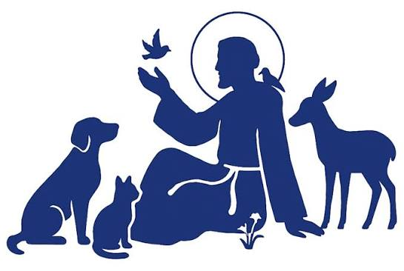
THE FEAST OF SAINT FRANCIS
BLESSING OF ANIMALS
October 4th, is the feast of Saint Francis. It is the traditional day the Catholic Church blesses pets and animals. The Blessing of Animals gives witness to God's and the Church's love, care, and concern for creation. As we recognize our mutual interdependence with God's creatures, the Church's witness of stewardship of creation is strengthened. It is also a service with special appeal to children. This year the Blessing of Pets and Animals will take place in front of the statue of Saint Francis on the Sacred Heart Campus located between the Rectory and the school building on Sunday, October 4th at 10:00PM. We ask our Religious Ed kids to bring your pets from home as well as any other parishioner who would like to participate in the blessing ceremony. The children will then return to class and the pets will be given back to the parents.


If you have not registered your children for class, please do so as soon as possible. Registration forms can be found on our web page and in the vestibule of our churches.

RETROUVAILLE
Retrouvaille: Rediscover the Love in Your Marriage Retrouvaille (pronounced Retro-vy). The program helps couples improve communication, increase intimacy, and find support during marriage problems, difficulties, or crises. The next program will be held October 2–4 at the Family Life Center in Malvern, PA. For more information visit MarriageHelpDelVal.org
SUMMER SERIES OF THE USA SAINTS
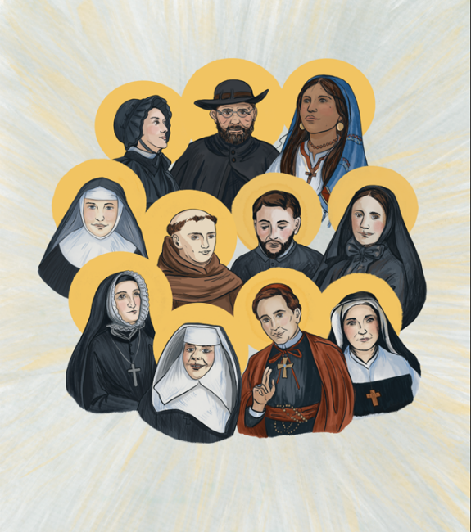
Our summer series of information of the 13 United States Saints has concluded. Thank you for your interest in their holy lives.

OCTOBER THE MONTH OF THE ROSARY
The month of October each year is dedicated to the Most Holy Rosary. This is primarily due to the fact that the liturgical feast of Our Lady of the Rosary is celebrated annually on October 7. It was instituted to honor the Blessed Virgin Mary in gratitude for the protection that she gives the Church in answer to the praying of the Rosary by the faithful. The Rosary is appealing and simple. The purpose of the Rosary is to help us meditate on the great mysteries of our salvation. Every time we pray the Our Father we are reminded that Jesus’ Father is the initiator of salvation. Praying the Hail Mary reminds us that we are joining with Mary in contemplating these mysteries. In addition, they help to make us aware that Mary was and is still intimately joined with her son, Jesus, in all the mysteries of earthly and heavenly existence. The constant repetition of prayer creates an atmosphere of contemplation.
The traditional fifteen Mysteries of the Rosary were finalized by the sixteenth century. The mysteries are grouped into sets: the Joyful Mysteries, the Sorrowful Mysteries, the Glorious Mysteries, and, in 2002, Pope John Paul II announced the new Luminous Mysteries.

HOW TO PRAY THE ROSARY

1. Make the Sign of the Cross and say the “Apostles’ Creed.” 2. Say the “Our Father.” 3. Say three “Hail Mary’s.” 4. Say the “Glory Be.” 5. Announce the First Mystery; then say the “Our Father.” 6. Say ten “Hail Mary’s,” while meditating on the Mystery. 7. Say the “Glory Be,” 8. Announce the Second Mystery; then say the “Our Father.” Repeat 6 and 7 and continue with Third, Fourth and Fifth Mysteries in the same manner. 9. Say the “Hail Holy Queen.”
In the name of the Father and of the Son and of the Holy Spirit. Amen.
Apostles’ Creed
I believe in God, the Father almighty, Creator of heaven and earth, and in Jesus Christ, his only Son, our Lord, who was conceived by the Holy Spirit,
born of the Virgin Mary, suffered under Pontius Pilate, was crucified, died and was buried; he descended into hell; on the third day he rose again from the dead; he ascended into heaven, and is seated at the right hand of God the Father almighty; from there he will come to judge the living and the dead. I believe in the Holy Spirit, the holy catholic Church, the communion of saints, the forgiveness of sins, the resurrection of the body, and life everlasting. Amen.
Our Father Our Father, who art in heaven, hallowed be Thy name, Thy kingdom come, Thy will be done, on earth as it is in heaven. Give us this day our daily bread, and forgive us our trespasses as we forgive those who trespass against us, and lead us not into temptation, but deliver us from evil. Amen.
Hail Mary Hail Mary, full of grace, the Lord is with thee; blessed art thou among women, and blessed is the fruit of thy womb, Jesus. Holy Mary, Mother of God, pray for us sinners, now and at the hour of our death. Amen.
Glory Be Glory be to the Father, and to the Son, and to the Holy Spirit. As it was in the beginning, is now, and ever shall be, world without end. Amen.
Hail Holy Queen Hail Holy Queen, Mother of mercy! Hail, our life, our sweetness and our hope! To you do we cry, poor banished children of Eve; to you do we send up our sighs, mourning and weeping in this valley of tears! Turn then, most gracious advocate, our eyes of mercy toward us; and after this, our exile, show unto us the blessed fruit of your womb, Jesus. O clement, O loving, O sweet Virgin Mary! V. Pray for us, Holy Mother of God. R. That we may be made worthy of the promises of Christ. Let us pray. O God, whose only begotten Son, by his Life, Death and Resurrection, has purchased for us the rewards of eternal life, grant, we beseech you, that we who meditate on these mysteries of the most holy Rosary of the blessed Virgin Mary, may both imitate what they contain and obtain what they promise, through the same Christ our Lord. Amen.
MYSTERIES
JOYFUL MYSTERIES (Monday and Saturday) Annunciation; Visitation; Nativity; Presentation; Finding in the Temple
THE MYSTERIES OF LIGHT (Thursday) Baptism of Jesus in the Jordan; Manifestation of Jesus at the Wedding at Cana; Proclamation of the Kingdom of God; Transfiguration of Jesus; Institution of the Eucharist
SORROWFUL MYSTERIES (Tuesday and Friday) Agony in the Garden; Scourging at the Pillar; Crowning with Thorns; Carrying of the Cross; Crucifixion
GLORIOUS MYSTERIES (Wednesday and Sunday) Resurrection; Ascension; Descent of Holy Spirit; Assumption; Coronation of the Blessed Virgin Mary

STATE-WIDE MASS FOR LIFE
OCTOBER 8
CATHOLICS AND PEOPLE OF GOOD WILL FROM ACROSS THE STATE will gather in prayer and public witness for the unborn during a day of events Oct. 8 in Trenton at a pivotal time for the pro-life movement. “Catholics in New Jersey live in the very challenging reality of [an] extreme abortion-permissive culture, which is even more reason for us to gather in Trenton in force as a united front, under the prayerful leadership of all our bishops,” said Rachel Hendricks, diocesan coordinator of respect life ministry.
The first stop for the faithful will be the NJ Bishops’ Mass for Life. Bishop David M. O’Connell, C.M., Diocese of Trenton, will be the host and principal celebrant of the Mass, which will begin at 9:30 a.m. in St. Mary of the Assumption Cathedral. Auxiliary Bishop Pedro Bismarck Chau of the Archdiocese of Newark will serve as the homilist.

BISHOP’S ANNIVERSARY BLESSING MASS
Join us in celebrating Marriage as we recognize those couples celebrating their first, twenty-fifth, or fiftieth (plus) year of marriage.
Cathedral of St. Mary of the Assumption
On Sunday, October 4th, the diocese will celebrate those couples in Burlington and Mercer counties at the Cathedral in Trenton. On Sunday, October 18th, is for couples in Monmouth and Ocean Counties at the Co-Cathedral in Freehold. We hope that you will join us this year in celebrating this beautiful vocation and sacrament. Both Masses begin at 3:00 PM.

Lost a loved one recently?
A five week introduction to Loss and
Grief is beginning soon. Come walk with
us as you navigate life after loss.
Details at www.stdavidtheking.com/bereavement
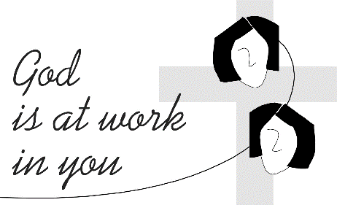
Regional Rosary Altar Mass
Join fellow parishioners for the 22nd Annual Regional Mass and fellowship breakfast!
When: Saturday, October 17, 2026 at 9:00 AM
Where: St. Raphael-Holy Angels Parish
Celebrants: Bishop David M. O'Connell & Priests
Continental breakfast following Mass ($20 per person) All are welcome!

CAPITAL SINGERS OF TRENTON

20th Anniversary Gala!
Sunday, October 18
Mercer Oaks Country Club
Capital Singers of Trenton proudly announces its 20th Anniversary Gala, with live entertainment, silent auction, dinner, and cash bar, celebrating two decades of musical excellence, community engagement, and artistic achievement.

Time & Location
Oct 18, 2026, 6:00 PM
Mercer Oaks Country Club, 725 Village Rd W, West Windsor Township, NJ 08550, USA

About this Event
The anniversary celebration will bring together supporters, alumni, community leaders, and music lovers for an elegant evening honoring the organization’s history and impact throughout the Greater Trenton region. Guests can expect an inspiring program featuring live performances, reflections on the organization’s journey, and recognition of the individuals and supporters who have helped shape Capital Singers of Trenton over the past twenty years.

OFFERINGS AT FRANCIS HOUSE OF PRAYER
Trenton Diocesan Spiritual Center and Retreat House
84 Walnford Road • Allentown, NJ 08501
609-877-0509 or FHOP@verizon.net
IN-PERSON ONLY CELEBRATE ST. FRANCIS
Sunday, October 4 11:00 AM –2:00 PM
We will have a wonderful celebration of St. Francis on his feast day! We begin with Mass at 11 AM, followed by lunch. We will view a brief film by Bishop Robert Barron on St. Francis. You will feel like you are in Assisi! Weather and time permitting, we will spend some time outdoors enjoying the beauty of creation as Francis insists. We will provide lunch.

