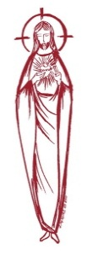
SACRED HEART PARISH

Sacred Heart Parish Founded 1814, The First Catholic Parish in the STate of New Jersey

Sacred Heart Church, 343 South broad Street, Trenton, New Jersey 08608

Holy Cross Church, 233 Adeline Street, Trenton, New Jersey 08611

ALL ARE WELCOME

Whatever your present status in the Catholic Church, whatever your current family or marital situation,

Whatever your past or present religious affiliation, whatever your personal history, age, background, or

race, whatever your own self-image or esteem, you are invited, welcomed, accepted, loved and

respected at the Parish of the Sacred Heart.

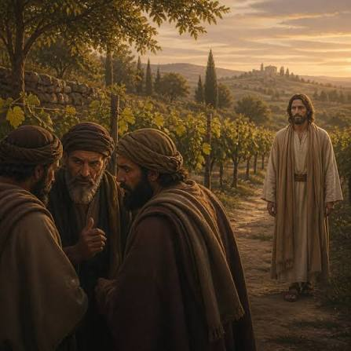

`This is the heir; come, let us kill him, and the inheritance will be ours.’

PASTOR

Rev. Msgr. Dennis A. Apoldite
frdennis@trentonsacredheart.org
PAROCHIAL VICAR
Rev. Charles Muorah 609-393-4826 ext. 108
DEACON : Dr. Christian Nnajiofor
Business ADMINISTRATOR/ADMINISTRATIVE ASSISTANT
John DeSantis: secretary@trentonsacredheart.org
Administrator of religious education
Mary Tovar: reled@trentonsacredheart.org

SACRED HEART PARISH OFFICE

9:00am – 4:00pm Monday – Friday

343 South Broad Street, Trenton, NJ 08608

Phone: (609) 393-2801 ~ Fax: (609) 989-8997 www.trentonsacredheart.org

Sacred Heart CHURCH
Monday, Tuesday, Wednesday and Friday: 12:10 Noon
Saturday 5:15 PM Sunday 9:00 and 11:15 AM
HOLY CROSS CHURCH
Saturday 4:00 PM Sunday 10:00 AM ~ 12:00 Noon Polish
EUCHARISTIC ADORATION
First Saturday of the Month 2:30 to 3:30 pm in HCC
SACRAMENTAL RECORDS
Sacred Heart Church, Saint John’s Church, Saint Francis Church, Saints Peter and Paul Church, Saint Stanislaus Church, Holy Cross Church, Blessed Sacrament Church, Our Lady of Divine Shepherd Church, Blessed Sacrament/Our Lady of Divine Shepherd Parish and Divine Mercy Parish

TWENTY-SEVENTH SUNDAY IN ORDINARY TIME

OCTOBER 4, 2026
MASS INTENTIONS
Saturday, October 3
4:00 pm HC~ Thomas Lukowicz and Ronald Carver
5:15 pm SH ~ Theresa Scurato, and Reneé Dellaira
Sunday, October 4
9:00 SH ~ Harold Lynch, Sr. & Mercedes Lynch, and
Living & Deceased Members of the Altar Rosary Society
10:00 HC ~ intentions of the People of the Parish
11:15 SH ~Irene McDermott
12:00 HC Polish ~ Fr. John Wake
Monday, September 5
12:10 SH ~ Grace Roper
Tuesday, September 6
12:10 SH ~ Special Intention
Wednesday, September 7
12:10 SH ~ Kevin Larkin
Thursday, October 8
12:10 SH ~ No Mass
Friday, October 9
12:10 ~ Special Intentions, Mary, Baby Noah, & Christine
Saturday, October 10
4:00 pm HC~ Dolores & Stanley Krysztofik,
Glazewski Brothers, and the Holy Name Society
5:15 pm SH ~ Theresa & Frank Scurato, and Reneé Dellaira
Sunday, October 11
9:00 SH ~ Ken & Lucille Fisher, and Brian McEvilly, Sr.
10:00 HC ~ Lee Lugossy
11:15 SH ~ Eileen Kostrzewa and Special Intention
12:00 HC Polish ~ intentions of the People of the Parish

OUR SICK LIST
Christopher, The Twin Girls, Rennetta Kinniebrew, John Walker, Barbara Burrows, Elizabeth Gorrel, Ellen Dondero, Stephanie McGinley, Dolores Lukowicz, Lesia DiVeonica, Alice Buck, Heather Allaire, Ronald & Lorraine Karczewski, John Hardiman, John Testa, Marlene Harris, Karen Vernon-Stewart, Diane Sabourin, Chet Siwczak, Donna Brodowski Longo, Tim Kuser, Susan Smith, Carol McDonough, Jim Duncan, Alexander Jaeploe, Nepoleon Jaeploe, Jean Ianni, Susan McCool, Doris Feehan, Anthony Pitonyak, Mary Komjathy, Fr J C Garret, Anna Solack, Lois Gold, Augustine Chavez, Lynda Costantini, Robert Paci, Dolores Klama, Nancy Dee, Judy Dee, Jon Arch, Bob Kuzma, Alexander Ladnyk, Michael Szymelewicz, Deahtron Wm. Crosland, Gerald Caruso, Paul Sootkoos, Richard Buckley, Joan Buckley, Kevin Hogan, Connie Swiderski, Thomas Erni, Michael Simoliga, Laverne Major, David Carver, Doreen Nemeth, Vincent Cooper Jr., Barbara Ardery, Karl Megules, Dan Breese Jr., Joseph Caivano, Greg Schafer, Chris, Tom, Melvin Lee, Amy Birk.
OUR DECEASED
Lorraine Rogers, James Biesaida Jr., and Joseph Di Paolo, Kathleen Waldron, and our friends at South Village, Riverside Nursing and Rehabilitation Center, Mill House and Trenton Gardens Rehabilitation and Nursing Center.

MINISTRY SCHEDULE
(Subject to change)

Saturday, October 3
4:00pm HCC ~ Fr Charles L.: V Zielinski EM: F Zielinski
5:15pm SHC ~ Msgr. Dennis L.: Willever Em Breuer’s
Sunday, October 4
9:00 SHC ~ Msgr. Dennis L.: Tovar EM Mowenn, Myers, Nagbe
10:00 HCC ~ Fr. Charles L.: Adorowa EM Kollie
11:15 SHC ~ Msgr. Dennis L.: Allen EM Allaire Bautz
12:00 HCC Polish ~ TBA L: Ewa, Gosia

Saturday, October 10
4:00pm HCC ~ Fr Charles L.: Manger EM: Benitez
5:15pm SHC ~ Msgr. Dennis L.: C Hernandez Em Burke, DuMont
Sunday, October 11
9:00 SHC ~ Msgr. Dennis L.:Y Laurenti EM Destin, Ortiz, Wengryn
10:00 HCC ~ Fr. Charles L.: Dodson EM Nnadi
11:15 SHC ~ Msgr. Dennis L.: Blizard EM Boyle Parasimo
12:00 HCC Polish ~ TBA L: Anna, Rysiu

A PRAYER FOR OUR MILITARY
Lord, hold our troops in your loving hands. Protect them as they protect us. Bless them and their families for the selfless acts they perform for us in our time of need. We ask this in the name of Jesus, our Lord and Savior…Amen.
Ricky Bailey, Jr
Sergeant Isabel Marie Figueroa
Staff Sergeant Nathaniel King
Terrance Livingston, Jr.
LT Madeleine Rizzuto USCG
1stLt Wayne D. Staub USMC

WEEKLY COLLECTION
Last weekend’s collection amounted to: $5,767.00
Capital Campaign ~ Project 210 ~ Completed
Total Donations $314,423.00
Annual Catholic Appeal Goal: $39,000.00
Pledged: $54,177.00 (139%) Paid: $51,861.00 (133%)
Total Donors: 154 (100%)
Readings for the Week
Twenty-seventh Week in Ordinary Time
Sunday Is 5:1-7; Phil 4:6-9; Mt 21:33-43
Monday Gal 1:6-12; Lk 10:25-37
Tuesday Gal 1:13-24; Lk 10:38-42
Wednesday Gal 2:1-2, 7-14; Lk 11:1-4
Thursday Gal 3:1-5; Lk 11:5-13
Friday Gal 3:7-14; Lk 11:15-26
Saturday Gal 3:22-29; Lk 11:27-28

PROMISE TO PROTECT
The Diocese of Trenton is committed to the norms of the U.S. Bishop’s Charter for the Protection of Children and Young People in regard to the reporting and investigation of sexual abuse allegations involving minors. If you have been sexually abused as a minor by anyone representing the Catholic Church, you can report that abuse through the diocesan Hotline: abuseline@dioceseoftrenton.org or 1-888-296-2965. Allegations are reported to the appropriate law enforcement agencies.

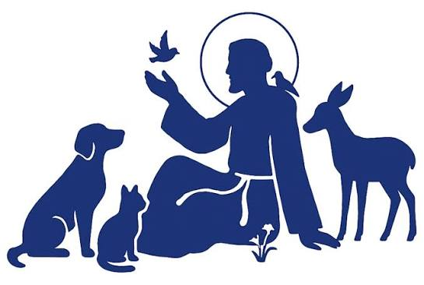
BLESSING OF ANIMALS
October 4th, is the traditional feast of Saint Francis. (This year because it falls on a Sunday, the Sunday celebration takes precedence.) It is the traditional day the Catholic Church blesses pets and animals. The Blessing of Animals gives witness to God's and the Church's love, care, and concern for creation. As we recognize our mutual interdependence with God's creatures, the Church's witness of stewardship of creation is strengthened. It is also a service with special appeal to children. This year the Blessing of Pets and Animals will take place in front of the statue of Saint Francis on the Sacred Heart Campus located between the Rectory and the school building on Sunday, October 4th at 10:00 AM. We ask our Religious Ed kids to bring your pets from home as well as any other parishioner who would like to participate in the blessing ceremony. The children will then return to class and the pets will be given back to the parents.

HALLOWEEN TREATS FOR THOSE IN NEED
This year, we are pleased to extend our Outreach Program to include Halloween treats for our neighbors in need. We look forward to preparing 200 “Trick-or-Treat” bags to be distributed along with our regular Food Distribution on October 20th. Our 7th and 8th grade Religious Education students will be preparing the bags for distribution. We invite parishioners who would like to participate in this autumn project to bring Halloween treats for the children on the weekend of October 10th and 11th. This will allow our students sufficient time to prepare the bags. Thank you for continually enriching our Outreach Program through your generous hearts and ongoing support.

ALTAR ROSARY SOCIETY

The Altar Rosary Society will meet on October 4, 2026, at Sacred Heart Church. Recitation of the Rosary will begin at 8:30am, we would love to have you join us in praying the Rosary and attending the Mass at 9:00am. Following Mass a meeting is held in Toomey Hall along with light refreshments. We are always looking for new members to praise and honor the Blessed Virgin Mary. Feel free to bring a friend or family member to meet our members and see firsthand what the Altar Rosary Society represents. New ideas, new members, welcome new ways to build our church community through parish life, charitable works and fellowship. Any questions, do not hesitate to contact Mrs. Carmen Benitez, at 609-954-3058.

HOLY NAME SOCIETY

The monthly meeting of the Holy Name Society will be held on Friday, October 9th at 7:00 pm in Toomey Hall. Any parish member 18 or over is welcome to attend the meeting to learn more about the Society's mission and our contributions to the parish and the Mercer County Federation of Holy Name Societies. For the month of October we are moving our Corporate Communion from Sunday 9:00 mass at Sacred Heart to the Saturday 4:00 p.m. mass at Holy Cross Church. We hope that you will be able to join us at our meeting on Friday and or Corporate Communion of Saturday evening.

MONTH OF THE ROSARY
The month of October is dedicated to the Most Holy Rosary. The liturgical feast of Our Lady of the Rosary is celebrated annually on October 7. It was instituted to honor the Blessed Virgin Mary in gratitude for the protection that she gives the Church in answer to the praying of the Rosary by the faithful. During the month of October, let us consider this beautiful prayer of the Rosary as a means that we too can use in order to draw closer to Jesus and Mary by meditating on the great mysteries of our salvation.


REGISTRATION
If you have not registered your children for class, please do so as soon as possible. Registration forms can be found on our web page and in the vestibule of our churches.

CONFIRMATION COVENANT SIGNING
Next Sunday, October 11th at the 9:00am Mass, the seventh grade students, preparing for the Sacrament of Confirmation, will be asked to sign a ‘Covenant’ to commit themselves to participate fully in our Confirmation process. Their parents will be a witness to this promise. Please remember them in your prayers as they proceed on their individual journeys toward the completion of the Sacraments of Initiation.

PARENT/STUDENT MEETING FOR GRADE 8
Following Mass the 9:00 Mass, the eighth students and parents will meet in the Church for a meeting regarding the Sacrament of Confirmation. This year’s Confirmation date is set for May 4th at 6:00 pm.

FRANCIS HOUSE OF PRAYER
84 Walnford Road,
Allentown, NJ 08501 FHOP@verizon.net
CARING FOR YOUR NEGATIVE FEELINGS
October 16–18 6:30 PM Friday–10:00 AM Sunday
Caring for your negative feelings is one of the kindest things you can do for yourself. Learn to carry them in such a way that they are healed from within and no longer weigh you down. If you are troubled by your negative emotions, pack them up and bring them along! Donation: $250/$100 non-refundable deposit with registration. Balance is required 2 weeks in advance of the start date.

STATE-WIDE MASS FOR LIFE
OCTOBER 8
CATHOLICS AND PEOPLE OF GOOD WILL FROM ACROSS THE STATE will gather in prayer and public witness for the unborn during a day of events Oct. 8 in Trenton at a pivotal time for the pro-life movement. “Catholics in New Jersey live in the very challenging reality of [an] extreme abortion-permissive culture, which is even more reason for us to gather in Trenton in force as a united front, under the prayerful leadership of all our bishops,” said Rachel Hendricks, diocesan coordinator of respect life ministry.
The first stop for the faithful will be the NJ Bishops’ Mass for Life. Bishop David M. O’Connell, C.M., Diocese of Trenton, will be the host and principal celebrant of the Mass, which will begin at 9:30 a.m. in St. Mary of the Assumption Cathedral. Auxiliary Bishop Pedro Bismarck Chau of the Archdiocese of Newark will serve as the homilist.

CAPITAL SINGERS OF TRENTON

20th Anniversary Gala!
Sunday, October 18
Mercer Oaks Country Club
Capital Singers of Trenton proudly announces its 20th Anniversary Gala, with live entertainment, silent auction, dinner, and cash bar, celebrating two decades of musical excellence, community engagement, and artistic achievement.

Time & Location
6:00 PM at Mercer Oaks Country Club,
725 Village Rd W, West Windsor Township.
The anniversary celebration will bring together supporters, alumni, community leaders, and music lovers for an elegant evening honoring the organization’s history and impact throughout the Greater Trenton region. Guests can expect an inspiring program featuring live performances, reflections on the organization’s journey, and recognition of the individuals and supporters who have helped shape Capital Singers of Trenton over the past twenty years.

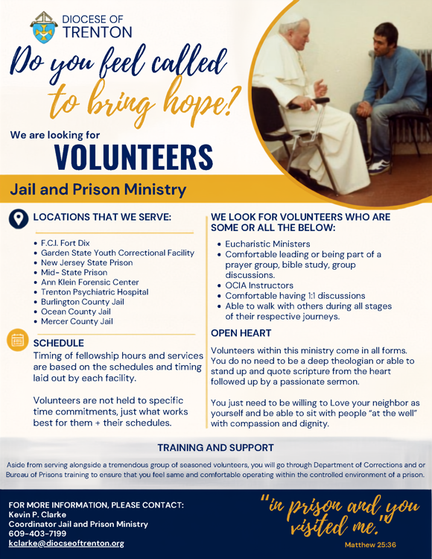

OCTOBER, RIGHT TO LIFE MONTH
MARY, MOTHER OF ALL LIFE
When the angel Gabriel appeared to Mary to tell her that she would conceive and bear a son, Mary responded with her fiat, “May it be done to me according to your word” (Lk 1:38). Mary conceives Christ in her womb, becoming the mother of God, the mother of Jesus. Jesus himself tells us that he is “the way and the truth and the life” (Jn 14:6). In becoming the mother of Jesus, Mary becomes the mother of life. Mary’s acceptance in this unforeseen moment demonstrates how each of us must welcome the gift of new human life, even when that gift is unexpected or calls us to make sacrifices.
​Eve was called the “mother of all the living” (Gen 3:20). Unfortunately, her disobedience brought sin into the world. In contrast Mary, through her obedience to God, gives birth to our Salvation. Mary becomes the New Eve—the new mother of all the living. Her fiat gives us an example of perfect docility and cooperation with the will of God.
At the Annunciation, when Mary learns that her elderly cousin Elizabeth is six months pregnant, she travels in haste to visit Elizabeth, spending the next three months at her side, even while pregnant herself. In her selfless service to Elizabeth, the Blessed Mother perfectly models how we are called to accompany expectant mothers as they prepare to welcome new life into the world.
Mary’s role as the Mother of Life extends from the Annunciation all the way to the Crucifixion. On Calvary, Mary stands at the foot of the Cross with Saint John. The Gospel tells us: “When Jesus saw his mother and the disciple there whom he loved, he said to his mother, ‘Woman, behold, your son.’ Then he said to the disciple, ‘Behold, your mother.’ And from that hour the disciple took her into his home” (Jn 19:26-27).
With his final breaths on the Cross, Jesus entrusts Mary and the Beloved Disciple to one another, and by extension establishes a maternal relationship between Mary and the Church. Jesus’ words are addressed not only to Saint John, but to each one of us. In this moment, the physical mother of Jesus becomes the spiritual mother of the Church and all the faithful. Saint John goes on to take Mary into his home and cares for her as she advances in age, demonstrating our responsibility to continue our care for human life, from conception to natural death. Mary, who taught us how to nurture human life, becomes the recipient of that same honor and care.
The life of the Blessed Mother teaches us to respect each human life in every stage and circumstance. Mary is our model for upholding the sanctity of all human life. O Mary, “Mother of the living, to you do we entrust the cause of life.”

