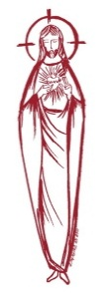
SACRED HEART PARISH

Sacred Heart Parish Founded 1814, The First Catholic Parish in the STate of New Jersey

Sacred Heart Church, 343 South broad Street, Trenton, New Jersey 08608

Holy Cross Church, 233 Adeline Street, Trenton, New Jersey 08611

ALL ARE WELCOME

Whatever your present status in the Catholic Church, whatever your current family or marital situation,

Whatever your past or present religious affiliation, whatever your personal history, age, background, or

race, whatever your own self-image or esteem, you are invited, welcomed, accepted, loved and

respected at the Parish of the Sacred Heart.

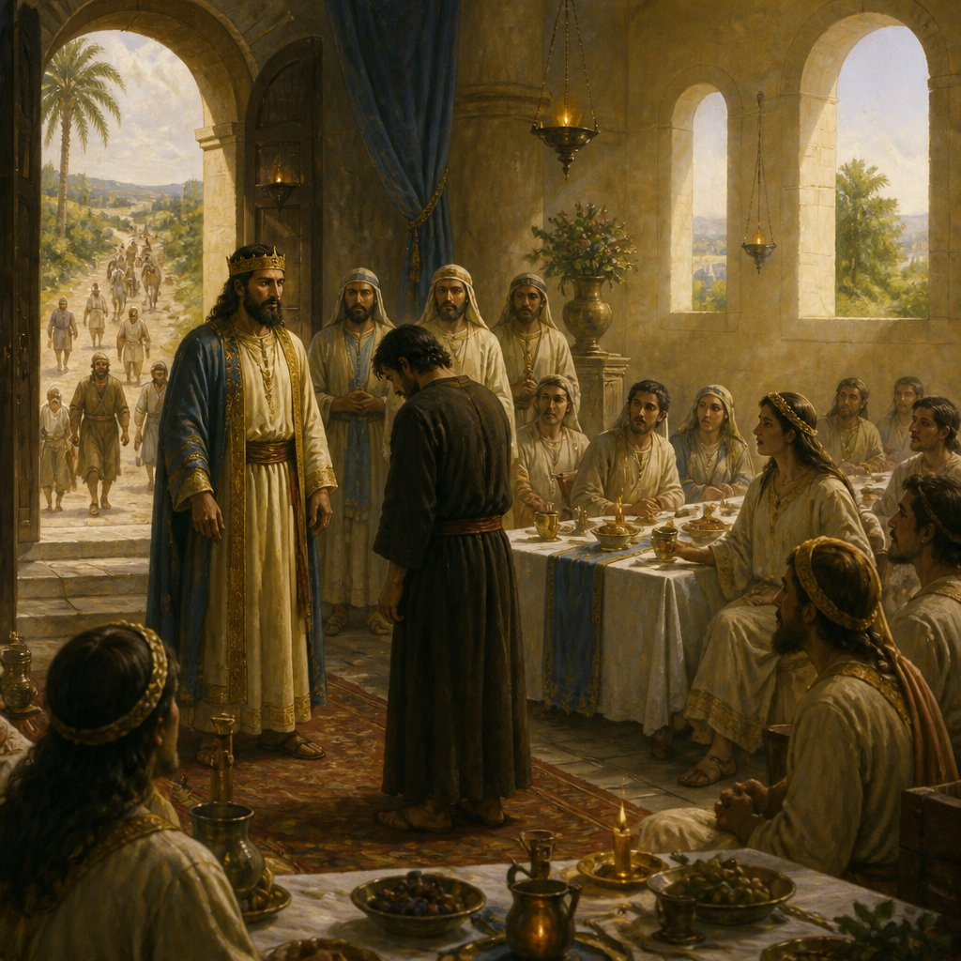

'My friend, how is it that you came in here without a wedding garment?'

PASTOR

Rev. Msgr. Dennis A. Apoldite
frdennis@trentonsacredheart.org
PAROCHIAL VICAR
Rev. Charles Muorah 609-393-4826 ext. 108
DEACON : Dr. Christian Nnajiofor
Business ADMINISTRATOR/ADMINISTRATIVE ASSISTANT
John DeSantis: secretary@trentonsacredheart.org
Administrator of religious education
Mary Tovar: reled@trentonsacredheart.org

SACRED HEART PARISH OFFICE

9:00am – 4:00pm Monday – Friday

343 South Broad Street, Trenton, NJ 08608

Phone: (609) 393-2801 ~ Fax: (609) 989-8997 www.trentonsacredheart.org

Sacred Heart CHURCH
Monday, Tuesday, Wednesday and Friday: 12:10 Noon
Saturday 5:15 PM Sunday 9:00 and 11:15 AM
HOLY CROSS CHURCH
Saturday 4:00 PM Sunday 10:00 AM ~ 12:00 Noon Polish
EUCHARISTIC ADORATION
First Saturday of the Month 2:30 to 3:30 pm in HCC



TWENTY-EIGHTH SUNDAY IN ORDINARY TIME

OCTOBER 11, 2026
MASS INTENTIONS
Saturday, October 10
4:00 pm HC~ Dolores & Stanley Krysztofik,
Glazewski Brothers, and the Holy Name Society
5:15 pm SH ~ Theresa & Frank Scurato, and Reneé Dellaira
Sunday, October 11
9:00 SH ~ Ken & Lucille Fisher, and Brian McEvilly, Sr.
10:00 HC ~ Lee Lugossy
11:15 SH ~ Eileen Kostrzewa and Special Intention
12:00 HC Polish ~ intentions of the People of the Parish
Monday, October 12 ~ Columbus Day
12:10 SH ~ No Mass
Tuesday, October 13
12:10 SH ~ Ann & Ray Kostura
Wednesday, October 14
12:10 SH ~ Vincent McIntyre
Thursday, October 15
12:10 SH ~ No Mass
Friday, October 16
12:10 ~ Frances Minelli
Saturday, October 17
4:00 pm HC~ Martin Maccaroni and Ronald Brodowski
5:15 pm SH ~ Lilly Hernandez, Theresa & Frank Scurato,
and Elizabeth McEwan
Sunday, October 18
9:00 SH ~ Juan Ramon Davila,
and Elizabeth & John McEwan
10:00 HC ~ intentions of the People of the Parish
11:15 SH ~ Donald Crusen
and Patricia & Karen Romanowsky
12:00 HC Polish ~ Deceased Priests of Trenton

OUR SICK LIST
Dora Marina Lopez, Christopher and Karen, The Twin Girls, Rennetta Kinniebrew, John Walker, Barbara Burrows, Elizabeth Gorrel, Ellen Dondero, Stephanie McGinley, Dolores Lukowicz, Lesia DiVeonica, Alice Buck, Heather Allaire, Ronald & Lorraine Karczewski, John Hardiman, John Testa, Marlene Harris, Karen Vernon-Stewart, Diane Sabourin, Chet Siwczak, Donna Brodowski Longo, Tim Kuser, Susan Smith, Carol McDonough, Jim Duncan, Alexander Jaeploe, Nepoleon Jaeploe, Jean Ianni, Susan McCool, Doris Feehan, Anthony Pitonyak, Mary Komjathy, Fr J C Garret, Anna Solack, Lois Gold, Augustine Chavez, Lynda Costantini, Robert Paci, Dolores Klama, Nancy Dee, Judy Dee, Jon Arch, Bob Kuzma, Alexander Ladnyk, Michael Szymelewicz, Deahtron Wm. Crosland, Gerald Caruso, Paul Sootkoos, Richard Buckley, Joan Buckley, Kevin Hogan, Connie Swiderski, Thomas Erni, Michael Simoliga, Laverne Major, David Carver, Doreen Nemeth, Vincent Cooper Jr., Barbara Ardery, Karl Megules, Dan Breese Jr., Joseph Caivano, Greg Schafer, Chris, Tom, Melvin Lee, Amy Birk.

OUR DECEASED
Sister Katharine Brent, Eather Nicolai, The Grodnick Family, Lorraine Rogers, James Biesaida Jr., and Joseph Di Paolo, Sr., and our friends at South Village, Riverside Nursing and Rehabilitation Center, Mill House and Trenton Gardens Rehabilitation and Nursing Center.
MINISTRY SCHEDULE
(Subject to change)

Saturday, October 10
4:00pm HCC ~ Fr Charles L.: Manger EM: Benitez
5:15pm SHC ~ Msgr. Dennis L.: C Hernandez Em Burke, DuMont
Sunday, October 11
9:00 SHC ~ Msgr. Dennis L.:Y Laurenti EM Destin, Ortiz, Wengryn
10:00 HCC ~ Fr. Charles L.: Dodson EM Nnadi
11:15 SHC ~ Msgr. Dennis L.: Blizard EM Boyle Parasimo
12:00 HCC Polish ~ Fr Charles L: Anna, Rysiu

Saturday, October 17
4:00pm HCC ~ Fr Charles L.:V Zielinski EM: Bliznawiczus
5:15pm SHC ~ Msgr. Dennis L.: R Hernandez Em Farruggio’s
Sunday, October 18
9:00 SHC ~ Msgr. Dennis L.: Morales EM Cruz’s Elie
10:00 HCC ~ Fr. Charles L. Kollie: EM Kamah
11:15 SHC ~ Msgr. Dennis L.: J Laurenti EM Rizzuto,
12:00 HCC Polish ~ Fr Marian L: Ewa, Mieciu

A PRAYER FOR OUR MILITARY
Lord, hold our troops in your loving hands. Protect them as they protect us. Bless them and their families for the selfless acts they perform for us in our time of need. We ask this in the name of Jesus, our Lord and Savior…Amen.
Ricky Bailey, Jr
Sergeant Isabel Marie Figueroa
Staff Sergeant Nathaniel King
Terrance Livingston, Jr.
LT Madeleine Rizzuto USCG
1st LT Wayne D. Staub USMC

WEEKLY COLLECTION
Last weekend’s collection amounted to: $10,802.00
Annual Catholic Appeal Goal: $39,000.00
Pledged: $54,177.00 (139%) Paid: $51,861.00 (133%)
Total Donors: 154 (100%)

Readings for the Week
Sunday Is 25:6-10a; Phil 4:12-14, 19-20; Mt 22:1-14
Monday Gal 4:22-24, 26-27, 31—5:1; Lk 11:29-32
Tuesday Gal 5:1-6; Lk 11:37-41
Wednesday Gal 5:18-25; Lk 11:42-46
Thursday Eph 1:1-10; Lk 11:47-54
Friday Eph 1:11-14; Lk 12:1-7
Saturday Eph 1:15-23; Lk 12:8-12

PROMISE TO PROTECT
The Diocese of Trenton is committed to the norms of the U.S. Bishop’s Charter for the Protection of Children and Young People in regard to the reporting and investigation of sexual abuse allegations involving minors. If you have been sexually abused as a minor by anyone representing the Catholic Church, you can report that abuse through the diocesan Hotline: abuseline@dioceseoftrenton.org or 1-888-296-2965. Allegations are reported to the appropriate law enforcement agencies.


HALLOWEEN TREATS FOR THOSE IN NEED
This year, we are pleased to extend our Outreach Program to include Halloween treats for our neighbors in need. We look forward to preparing 200 “Trick-or-Treat” bags to be distributed along with our regular Food Distribution on October 20th. Our 7th and 8th grade Religious Education students will be preparing the bags for distribution. We invite parishioners who would like to participate in this autumn project to bring Halloween treats for the children on the weekend of October 10th and 11th. This will allow our students sufficient time to prepare the bags. Thank you for continually enriching our Outreach Program through your generous hearts and ongoing support.

HOLY NAME SOCIETY

For the month of October, our Corporate Communion Mass will be celebrated on Saturday October 10th at 4:00 p.m. in Holy Cross Church.

CONFIRMATION COVENANT SIGNING
Next Sunday, October 11th at the 11:15am Mass, the seventh grade students, preparing for the Sacrament of Confirmation, will be asked to sign a ‘Covenant’ to commit themselves to participate fully in our Confirmation process. Their parents will be a witness to this promise. Please remember them in your prayers as they proceed on their individual journeys toward the completion of the Sacraments of Initiation.

PARENT/STUDENT MEETING FOR GRADE 8
Following Mass the 9:00 Mass, the eighth students and parents will meet in the Church for a meeting regarding the Sacrament of Confirmation. This year’s Confirmation date is set for May 4th at 6:00 pm.

INVITATION TO OUR 2ND FELLOWSHIP CONTINENTAL BREAKFAST
The Altar Rosary Society and Holy Name Society of Sacred Heart Parish, warmly invite all parishioners to our upcoming 2nd Fellowship Continental Breakfast. We are excited for another opportunity to gather as a church family, share a delicious breakfast, and enjoy fellowship together in a relaxed atmosphere.
WHEN:
Sunday, November 8th, 10:15am to 1:30pm
WHERE:
Toomey Hall, Sacred Heart Church.
Join us for a time of connection and to strengthen our parish community. We can't wait to see you there!
Any questions, call Carmen @ 609-954-3058

CAPITAL SINGERS OF TRENTON

20th Anniversary Gala!
Sunday, October 18 ~ Mercer Oaks Country Club
Capital Singers of Trenton proudly announces its 20th Anniversary Gala, with live entertainment, silent auction, dinner, and cash bar, celebrating two decades of musical excellence, community engagement, and artistic achievement.

Time & Location
6:00 PM at Mercer Oaks Country Club,
725 Village Rd W, West Windsor Township.
The anniversary celebration will bring together supporters, alumni, community leaders, and music lovers for an elegant evening honoring the organization’s history and impact throughout the Greater Trenton region. Guests can expect an inspiring program featuring live performances, reflections on the organization’s journey, and recognition of the individuals and supporters who have helped shape Capital Singers of Trenton over the past twenty years.



COLUMBUS DAY
The parish office will be closed on Monday, October 13th. The 8:00 AM Mass at Holy Cross Church and the 12:10 noon Mass at Sacred Heart Church will not be celebrated. Enjoy a safe and restful holiday weekend!

MONTH OF THE ROSARY
The month of October is dedicated to the Most Holy Rosary. The liturgical feast of Our Lady of the Rosary is celebrated annually on October 7. It was instituted to honor the Blessed Virgin Mary in gratitude for the protection that she gives the Church in answer to the praying of the Rosary by the faithful. During the month of October, let us consider this beautiful prayer of the Rosary as a means that we too can use in order to draw closer to Jesus and Mary by meditating on the great mysteries of our salvation.

FOOD COLLECTION NEXT WEEKEND
Our October Food Collection is scheduled for next weekend. We are beginning to work on our inventory for our Thanksgiving food distribution and so are asking that you bring holiday items such as: boxed stuffing, gravy, cranberry sauce, canned vegetables, canned sweet potatoes, instant mashed potatoes and the like. We appreciate your generosity with the needy of our neighborhood.

MASS BOOK FOR 2027
Our Mass Intention Book for 2027 is now open for your requests. For the weekend Mass schedule, we will continue our policy of accepting three intentions per Mass. On weekdays and Holy Days we will schedule one intention per Mass. The stipend remains at $10.00 per intention. Contact the parish office to schedule your intentions.
NEXT WEEKEND: MISSION SUNDAY
Next weekend, October 17st & 18th has been designated as Mission Sunday throughout the world. Your generous contributions will be shared through our Propagation of the Faith Office to world mission communities. We ask that you keep all missionaries in your prayers as they strive to evangelize all they serve. In 1926 Pope Pius XI instituted Mission Sunday for the whole Church with the first worldwide Mission Sunday collection taking place in October 1927. That day is celebrated in all the local Churches as the feast of catholicity and universal solidarity so Christians the world over will recognize their common responsibility with regard to the evangelization of the world. There will be a second collection for the Missions.

OCTOBER MASS COUNT
For the next two weekends October 17 & 18 and October 24 & 25, the Office of Planning for the Diocese of Trenton has asked that every person be counted at each weekend Mass. The purpose of this annual count is to obtain an accurate total number attending Mass at each worship site on these weekends.

ALL SOULS REMEMBRANCE
Please remember to send in your All Souls Mass Remembrance Envelopes. These envelopes, with the names of your deceased loved ones, will be placed on the Altars during the month of November.
SOLEMN ST. JUDE NOVENA
St. Michael Church, 1106 Brunswick Avenue, Trenton, is celebrating the Solemn Novena of St. Jude from October 20th to the 28th.

OCTOBER PRAYER INTENTION OF
OUR HOLY FATHER, POPE LEO
Let us pray that the mental health ministry be established throughout the Church, helping to overcome the stigma and discrimination of persons with mental illnesses.

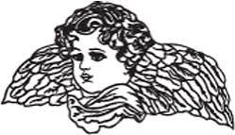
REMEMBER OUR DECEASED
Once again this year, we will continue our tradition of honoring all those who were buried from our parish between mid-October 2025 and mid-October 2026. If you would like to participate in this special ceremony, please bring a framed photograph of your deceased loved one (no larger than 5" x 7") to Mass on the weekend of October 31 and November 1. Please attach your name and phone number to the back of the photograph so that it can be returned to you.

During the Mass, the names of all the deceased will be read at each Mass. When the name of your deceased loved one is called, please come forward and place their photograph in the designated place. In Sacred Heart Church: Please go to the altar rail on the side of the rectory and place the photograph on the Table of Remembrance, then return to your seat. In Holy Cross Church: Please go to either the Altar of Saint Francis or the Altar of Our Lady of Czestochowa, place the photograph on the side altar, and then return to your seat. The photographs will remain on display until November 30. We warmly invite you to participate in this beautiful ceremony as we come together as a parish community to remember, honor, and pray for our beloved deceased. If a member of you family passed away over the last year and you would like to place a photograph of them on the designated altars, you will be given the opportunity to do so when the parishioners named have been read.

ALL SOULS REMEMBRANCE
Please remember to send in your All Souls Mass Remembrance Envelopes, with the names of your deceased loved ones. They will be placed on the Altars during the month of November.
SAINT MARGARET MARY ALACOQUE
Feast Day, October 16
Margaret Mary was chosen by Christ to arouse the Church to a realization of the love of God symbolized by the heart of Jesus.
Her early years were marked by sickness and a painful home situation. “The heaviest of my crosses was that I could do nothing to lighten the cross my mother was suffering.” After considering marriage for some time, Margaret Mary entered the Order of the Visitation nuns at the age of 24.
A Visitation nun was “not to be extraordinary except by being ordinary,” but the young nun was not to enjoy this anonymity. A fellow novice termed Margaret Mary humble, simple, and frank, but above all, kind and patient under sharp criticism and correction. She could not meditate in the formal way expected, though she tried her best to give up her “prayer of simplicity.” Slow, quiet, and clumsy, she was assigned to help an infirmarian who was a bundle of energy.
On December 21, 1674, three years a nun, she received the first of her revelations. She felt “invested” with the presence of God, though always afraid of deceiving herself in such matters. The request of Christ was that his love for humankind be made evident through her.
During the next 13 months, Christ appeared to her at intervals. His human heart was to be the symbol of his divine-human love. By her own love Margaret Mary was to make up for the coldness and ingratitude of the world—by frequent and loving Holy Communion, especially on the first Friday of each month, and by an hour’s vigil of prayer every Thursday night in memory of his agony and isolation in Gethsemane. He also asked that a feast of reparation be instituted.
Like all saints, Margaret Mary had to pay for her gift of holiness. Some of her own sisters were hostile. Theologians who were called in declared her visions delusions and suggested that she eat more heartily. Later, parents of children she taught called her an impostor, an unorthodox innovator. A new confessor, the Jesuit Claude de la Colombière, recognized her genuineness and supported her. Against her great resistance, Christ called her to be a sacrificial victim for the shortcomings of her own sisters, and to make this known. She died at the age of 43, while being anointed. She said: “I need nothing but God, and to lose myself in the heart of Jesus.”


ST. Raphael-Holy Angels Parish Mission

"You are Called to be a Saint" an evening with Fr. Raymond F. Walsh. Thursday October 29 at 7:00 PM in the Parish Center. Donations to support the food pantry are greatly appreciated. All are welcome. St. Raphael-Holy Angel Parish, 3500 South Broad Street, Hamilton.

Volunteers Needed

The Diocese of Trenton Jail and Prison Ministry is seeking volunteers to bring hope, compassion and the love of Christ to those in correctional and other secure facilities. Volunteers may participate in prayer groups, Bible studies, OCIA instruction, Eucharistic ministry, or one-on-one conversations. No specific schedule is required, and training and support are provided. To learn more, contact Kevin P. Clarke at 609-403-7199 or kclarke@dioceseoftrenton.org.

NOTRE DAME HIGH SCHOOL
OPEN HOUSE
Thursday October 22, 2026
6:00 PM - 8:00 PM
Experience the Notre Dame Difference
Don't just read about it—experience it for yourself. Join us for the Notre Dame High School Open House on October 22, 2026, from 6 PM to 8 PM. This is your opportunity to: Connect with the people who make our school great: Meet our teachers, coaches, and current students. Explore our campus: Get a firsthand look at our classrooms, athletic facilities, and more. Experience the energy of our community: Discover what makes Notre Dame a unique and supportive environment. The event is free and open to all families interested in a catholic school education.
ALTAR ROSARY REGINAL MASS
The 22nd Altar Rosary Regional Mass and Breakfast will be hosted by St. Raphael-Holy Angels Parish on Saturday morning, October 17. The Rosary begins at 8:40 AM, followed by Mass at 9:00 AM, celebrated by Bishop David O’Connell, and a Continental Breakfast. The cost is $20, and reservations are due to Dottie Trani by Monday, October 12.

A BORROWED THOUGHT …………….

God Loves Our Imperfections

God, to me, is a mystery, but in my better moments, I feel fairly sure that God loves us in the way I am trying to love my kids. That is to say, I think God looks at us and sees the beauty of who we are, and that beauty is not a result of our being perfect. It’s a result of our being a whole, unique mess—the good and the bad together. God delights in our discolored strands—at our wild imperfections. As a father myself, I am learning to do the same.

